Dear Dr. Çimen,
Enclosed please find the revised version of manuscript "OPG-RANKLLevels after Continuous Orthodontic Force".
Thank you for having reviewed the manuscript. We are also grateful to referees for constructive criticism and for their suggestions.Amendments made in the enclosed revision have been highlighted by red colored text. Replies for comments of the reviewers and changes in the manuscript are explained in detail below.
We hope that the revisions carried out now qualify for publication of our article in your distinguished journal.
Sincerely,
Doç.Dr. Burcu Baloş Tuncer
Reviewer 1.
1-A few typo errors:Abstract in turkish, line 9 “sonar” should be sonra
2-Introduction part, 3rd paragraph: consider changing tense: “Recent studies
have focused...”
3-Material and Methods part, GCF sampling paragraph, line 10-11 should be
“Precisa instruments Ag,...”
4-Table 1. Possibly typo error: SD's does not reflect the variation in min/max
values.The numbers related to the total amount of GCF had very small decimals, and since we gave the results as 3-digits the standard deviations were seen as 0.00. They are not absolute zero, if we would have given them as 10 ⁵, a very small value could have been given. A graphic related to GCF total amount is stated below. If it is required we can replace the table with the figure.

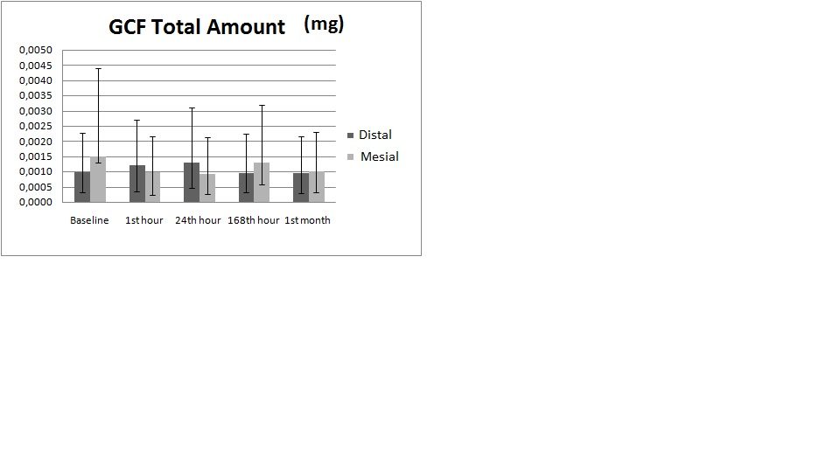5-“Table 4.” should be “Figure 4.”
6-Table 4 y-axis label should read “OPG concentration”
7-“Table 5.” should be “Figure 5.”
8-Table 5. y-axis label should read “RANKL concentration”
9-“Table 6.” should be “Figure 6.”
10-Table 6. y-axis label should read OPG/RANKL ratio”
All the required corrections stated above have been performed. In relation to the requests, concentration values of OPG and RANKL were given in tables, and total amounts were given in figures. Therefore, the table and figure numbers have been changed throughout the manuscript.
Questions concerning material and methods / results:
1-“Is it possible to weigh 1 μg using a semi micro balance?!? Usual semi microbalances are rated to measure 10 μg readings at best! As a rule of thumb,below this limit, it's not possible to perform reproducible readings. GCFweight measurements are likely to be artifactual rather than actual masses.”
We agree with the reviewer about the limitations and reproducibility problems of GCF amount detection methods, including semi micro balances. As the reviewer mentioned GCF weight measurements are likely to be artifactual rather than actual masses.To determine the amount of gingival crevicular fluid (GCF), an electronic scale was used for weighing the paper strips before and immediately after the collection. The difference between the two weighings gave the volume of fluid collected, assuming a specific gravity of approximately 1. Thus all numbers on GCF measures are given in µg. This measuring method has been published previously by us and the others ( Ulkar et al., Journal of Periodontology, 2012; BB Tuncer et al. Angle Orthod, 2005 Ozmeric et al., Journal of Periodontology 2002)
2-“Absolute values are presented, instead of OPG and RANKL concentrations. It's
tedious to try to apprehend the data in this representation. Concentration
values should be given instead of absolute amounts. Otherwise, the rationale
for representing absolute amounts should be explained.”
Concentration values related to OPG and RANKL are included in tables in the manuscript as suggested.
3-“Although obtained OPG values exceed detection limit of the OPG-ELISA kit,
almost all measurements fall below the lowest standard. Exterpolating the
nonlinear standard curve may (will) pose the risk of over/underestimating
actual concentrations. Furthermore, if the patient samples/technical
replicates are assayed at different time points, it will be completely
impossible to make an assessment. To be fair, i have to emphasize that,
there is no way to find a suitable commercial kit for this kind of study.
Therefore, it's quite understandable and acceptable to use those kits, but
wouldn't it be nice to extend the dilution series of standards to cover the
expected range of analyte.”
Limit of Detection in “Biovendor OPG Elisa kit” is defined as concentration of analyte giving absorbance higher than mean absorbance of blank* plus three standard deviations of the absorbance of blank: Ablank+ 3xSDblank, is calculated from the real human OPG values in wells and is 0.03 pmol/l.
*Dilution Buffer is pipetted into blank wells.

