Manuscript Type: Case Report

Pitfalls of Double Lumen Endotracheal Tube in Prone Position During a Thoracoscopic and Laparoscopic Assisted Esophagectomy (TLAE) : A Sabah Experience

Kai Ming Tan¹, Boon Tat Yeap², Sakuntala Dewi¹

¹Department of Anaesthesia and Critical Care, Queen Elizabeth Hospital, Kota Kinabalu, Sabah, Malaysia
²Medicine Based Department, Faculty of Medicine and Health Sciences, Universiti Malaysia Sabah, Kota Kinabalu, Sabah, Malaysia

*Corresponding author:
Boon Tat Yeap
Lecturer and Anaesthesiologist,
Medicine Based Department, Faculty of Medicine and Health Sciences, Universiti Malaysia Sabah, Kota Kinabalu, Sabah, Malaysia
Tel: 088-320000 ext. 611040
E-mail: yeapboontat@gmail.com
ORCID Number : 0000-0002-2517- 597X

ABSTRACT
This case report is about a young gentleman who was diagnosed with advanced achalasia cardia with mega-esophagus and underwent an elective thoracoscopic and laparoscopic assisted esophagectomy (TLAE) in prone position.
We highlight the challenges of maintaining correct placement of double lumen tube (DLT) while positioning the patient into prone position, as well as the use of fiberoptic bronchoscope (FOB) in troubleshooting dislodgement of DLT while pronated.
Keywords: Double lumen tube, prone position, dislodgement, fiberoptic bronchoscope.

Introduction:
Ventilating a patient using a double lumen tube (DLT) as part of lung isolation strategy constitutes a challenge to an anaesthetist. The challenge is heightened when the patient is put in the prone position. Malposition and displacement of tube, failure of lung isolation, hypoxemia is not uncommon. We share our invaluable experience troubleshooting DLT dislodgement in prone position in a case of elective thoracoscopic and laparoscopic assisted esophagectomy (TLAE).

Case Report:
This is a 28 years old lean built gentleman, who presented with symptoms of difficulty in swallowing fluids and epigastric pain with retrosternal burning sensation for the past 10 years. These symptoms has worsened over the past 2 years and is accompanied with repeated bouts of chest infections. An esophagogastroduodenoscopy (OGDS) revealed a very dilated esophagus with residual fluid of 800mls and food particles within it, and narrowed cardio-esophageal junction at level of 50cm (Figure 1 - 3). A CT Neck & Thorax reported a uniformly and grossly dilated esophagus measuring length of 24.9cm, width of 8.3cm and AP diameter of 4.6cm. A diagnosis of advanced achalasia cardia with mega-esophagus was made and he was planned for an elective TLAE.
A comprehensive cardiorespiratory workup was done preoperatively. This includes a CT Thorax which revealed bronchiectatic changes of the lungs bilaterally and lung fibrosis, likely as a result of the long standing chest infections secondary to micro-aspirations. Spirometry parameters were within normal range with FVC 79% and FEV1/FVC 77%. An echocardiogram was also done, which showed an ejection fraction of 77% with no valves and chambers abnormalities.
Our anaesthetic management included ensuring adequate fasting time of 8 hours and administration of drugs for aspiration prophylaxis preoperatively. Rapid sequence induction (RSI) of anaesthesia using intravenous Fentanyl 100mcg, Propofol 190mg, Rocuronium 60mg was performed in view of the risk of aspiration from remnants food particles trapped in the dilated esophagus. Cricoid pressure was maintained and the trachea was intubated with a size 37F Mallinckrodt left sided double lumen tube under direct laryngoscopic view. Post insertion, placement was confirmed clinically and with the use of FOB. The DLT was anchored at 27cm length with the bronchial cuff just visible when viewed with the FOB via the trachea lumen. With the bronchial cuff inflated with 3cc of air, one lung ventilation (OLV) was achieved.
The patient was then ventilated via both tracheal and bronchial lumen and was then carefully positioned into prone position. Throughout this process, the DLT was held in place and remained anchored at 27cm. However, we were not able to isolate the lungs once the patient was pronated. A careful check on the tracheal and bronchial cuffs showed both were adequately inflated. Hence the failure of lung isolation was likely due to the migration of the endobronchial tube during prone positioning.
We decided to proceed with FOB while the patient was in prone position with the patient’s head rotated slightly to the right side. FOB via the tracheal lumen showed that the bronchial cuff had migrated proximally and dislodged into the trachea (Figure 5). We deflated both the bronchial and tracheal cuff and navigated the bronchoscope into the left bronchus via the bronchial tube. The bronchial tube was then successfully guided back in place to the left bronchus. Once the bronchial and tracheal cuffs were re-inflated, we were then able to isolate both lungs.
Surgery commenced with a right thoracoscopy, whereby three trocars were inserted into the right thorax for the creation of capnothorax at pressure of 8 – 10 mmHg (Figure 4). The esophagus was mobilized proximally to distal. Intraoperatively, the patient’s peak airway pressures were kept between 14 – 18 cmH20 with tidal volume maintained at 8 – 10 ml/kg. Pulse oximetry was sustained at 95 – 97 % with fraction inspired oxygen (FiO₂) of 0.5. Patient’s haemodynamics were maintained with fluids and kept at mean arterial pressure of 65 – 75 mmHg. At the end of the thoracoscopic procedure, the CO₂ insufflation was ceased and a chest drain was inserted. The collapsed right lung was then visualized to be sufficiently reinflated under thorascopic view. After that, the patient was supinated whereby a laparoscopic pneumoperitneum was created. A neo-esophagus was created and the gastric pulled up through the left anterior neck incision and anastomosis was then, completed using stapler. Total duration of surgery was 350 minutes with duration of anaesthesia in prone position of 140 minutes. Blood loss was minimal at 600 mls.
Post operatively, the DLT was exchanged to a single lumen PVC endotracheal tube (ETT) size 7.5mm under direct laryngoscopy. The patient was weaned in the Intensive Care Unit (ICU) and extubated the next day. His recovery was uneventful and was subsequently followed-up at the surgical outpatient clinic.

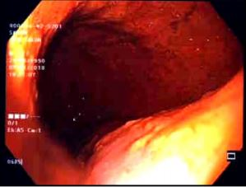
Figure 1 : OGDS view of the proximally dilated esophagus ( Achalasia).
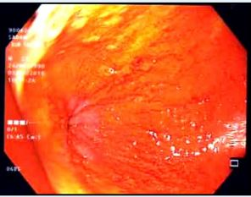
Figure 2: OGDS view of the distally constricted esophagus.
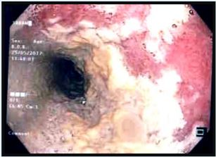
Figure 3 : OGDS view showing food remnants at esophagus.
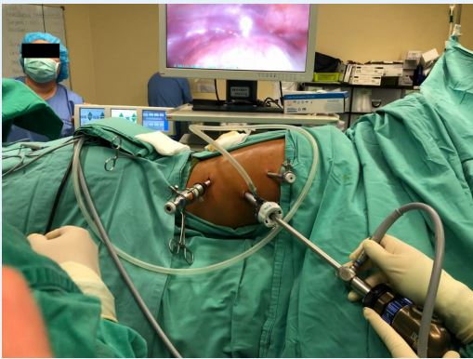
Figure 4: Right thoracoscopy with the patient in prone position.

Discussion:
With recent increase of minimally invasive surgeries including thoracoscopic assisted esophagectomy (TLAE), selective collapsed of a lung or one lung ventilation performed via DLT has become a necessary skill to be mastered by anaesthetists. Classically, DLT insertions are performed without a FOB. Rather, anaesthetists rely on clinical confirmation of OLV as a marker for successful DLT placement.
Movement of tube by 1cm proximally or distally results in malposition of DLT, as described by Inoe S. et. al.^{[1]} With such small margin of error, malposition of DLT are a common occurrence, and account for most cases of hypoxemia and failure of OLV.
Displacements of a DLT occurs, especially during repositioning of a patient to a lateral or prone position. Troubleshooting dislodgement of DLT is especially challenging to an anaesthetists, particularly while pronated.
With fiberoptic assessment, clarification of the cause of inadequate ventilation or insufficient lung separation are immediately possible. Strong evidence supports the routine use of bronchoscopy as a diagnostic as well as therapeutic tool in troubleshooting issues with DLT. ^{[2-4]}

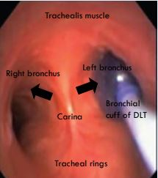
Figure 5: FOB view of the trachea anatomy in prone position with the tracheal rings located posteriorly and trachealis muscle at the anterior. The left blue bronchial cuff is seen herniating from the left bronchus.

In this particular case, FOB allowed direct visualization and recognition of the DLT malposition while remaining in prone position. In addition, navigating the FOB through the bronchial lumen of a DLT allowed the successful re-intubation of the appropriate bronchus without necessitating the hassle of re-intubating the patient in a supine position, should a blind technique is used.
Of a particular challenge was the FOB view in prone position, as most bronchoscope experience is in a supinated patient. Viewing the trachea in prone can be disorientating. However, with good knowledge of airway anatomy, FOB visualization of the tracheal rings and the posterior longitudinal muscles allowed us to identify the left and right bronchus without much difficulty.

Conclusion:
The routine use of fiberoptic bronchoscopy in DLT placement can be arguably more costly and time consuming.^{[5-6]} However, as demonstrated, it can be an essential tool in the re-intubation of a dislodged DLT particularly in prone position. It should be noted that an experienced FOB operator with good knowledge of airway anatomy is essential for the successful placement of a DLT in prone.
We thus recommend the routine use of fibreoptic bronchoscopy in troubleshooting DLT placement and urge anaesthetists to build a strong skillset in fiberoptic bronchoscopy and airway anatomy.

References:
- Inoue S, Nishimine N, Kitaguchi K, Furuya H, Taniguchi S. Double lumen tube location predicts tube malposition and hypoxemia during one lung ventilation. Br J Anaesth 2004; 92: 195–201

- Uwe Klein, Waheedullah Karzai, Frank Bloos, Mathias Wohlfarth, Reiner Gottschall, Harald Fritz, Michael Gugel, Albrecht Seifert; Role of Fiberoptic Bronchoscopy in Conjunction with the Use of Double-lumen Tubes for Thoracic Anesthesia : A Prospective Study. Anesthesiology 1998;88(2):346-350.

- Smith GB, Hirsch NP, Ehrenwerth J: Placement of double-lumen endobronchial tubes. Correlation between clinical impressions and bronchoscopic findings. Br J Anaesth 1986; 58:1317-20.

- Schottke-Hennings H, Klippe HJ, Schmieding B: Die Fiberbronchoskopie als Hilfsmittel zur Plazierung und Uberwachung von Doppellmentuben in der Thoraxanasthesie. [Fiber bronchoscopy as an aid in placing and monitoring double lumen tubes in thoracic anesthesia.] Anaesth Intensivther Notfallmed 1989; 24:327-33.

- Grum DF, Porembka D: Misconceptions regarding double-lumen tubes and bronchoscopy [letter]. Anesthesiology 1988; 68:826-7.

- Conacher ID, Herrema IH, Batchelor AM: Robertshaw double lumen tubes: A reappraisal thirty years on. Anaesth Intensive Care 1994; 22:179-83.

- Slinger PD. Fiberoptic bronchoscopic positioning of double-lumen tubes. J Cardiothorac Anesth 1989; 3: 486–96

