The prophylactic and protective effects of Terfezia Claveryi extracts on Ibuprofen induced oxidative stress in pregnant rats.

Mohammed Talat Abbas
Department of Pharmaceutical Chemistry, College of Pharmacy, kerbala university , kerbala-Iraq

E-mail: mohammedtalat_1981@yahoo.com

ABSTRACT

Objective: This study aimed to investigate the prophylactic and protective roles of Terfezia Claveryi extracts on Ibuprofen induced oxidative stress in pregnant albino rats.

Methods: Thirty pregnant rats randomly divided in to five experimental groups , each group consist of six pregnant rats. Group 1 (control group): without any treatment. Group 2 (Ibuprofen group): Given Ibuprofen orally by gastric tube at dose of 40 mg/kg/day for 20 days. Group 3 ( Terfezia Claveryi group): Received Terfezia Claveryi extracts via gavage at 250 mg/kg every day dose. Group 4 (Ibuprofen +Terfezia Claveryi group): Received with Ibuprofen at dose of 40 mg/kg every day plus Terfezia Claveryi extracts 250 mg/kg /day by gastric tube along the experiment. Group 5 ( Terfezia Claveryi + Ibuprofen): Received with 250 mg/kg every day of Terfezia Claveryi via gavage for two weeks before gestation (as a prophylactic ) and then treated with Ibuprofen at the above-mentioned dose at zero day of gestation to twenty day of the experiment.

Results: Ibuprofen increased serum AST, ALT, ALP activity, total bilirubin concentration, Liver tissue MDA levels and decreased liver tissue Catalase, Superoxide Dismutase and Glutathione Peroxidase. However, this modulation of the biological parameter is significantly ameliorated by the administration of the Terfezia Claveryi .

Conclusion:In conclusion prophylactic and protective effect of Terfezia Claveryi against Ibuprofen induced oxidative stress was reported in pregnant rats.

Key words : Ibuprofen , Terfezia Claveryi ,Oxidative stress , Pregnant rats.

Introduction

The shift in balance between reactive oxidants and antioxidants is called the oxidative stress. It is produced when the reactive oxygen species (ROS) are more than the antioxidant levels (1,2).Many conditions are associated with oxidative stress shortage of antioxidant vitamin, smoking, diseases, pollution and drug (3).

Ibuprofen, is an example of the non-steroidal anti-inflammatory drugs (NSAIDs) (4,5). It is one of the most commonly used NSAIDs for the relief of pains, fever and treatment of inflammatory conditions. The drug is recorded to be better and preferred for muscle and joint pain than most other NSAIDs and has been employed by patients with arthritis for years (6). The pharmacological actions of ibuprofen, like other NSAIDs, has been reported to be via inhibition of cyclooxygenase (COX) enzyme activity (7). Although, NSAIDs are considered to have high safety, the frequent and employ of ibuprofen and other NSAIDs is likely to increase the prevalence of their adverse effects. Ibuprofen and other NSAIDs are commonly associated with hepato , nephro and gastrointestinal (GI) toxicity (8,9). Many studies have shown the adverse effects of different NSAIDs to the kidney (10-12). In addition to that , Lateef , et al. (13) have recorded that NSAIDs may also change liver function, causing elevations of serum aspartate aminotransferase (AST) and alanine aminotransferases(ALT) and necrosis of hepatic cells.

Terfezia Claveryi grow naturally in different parts of the world, especially in the Arabian desert (14). Terfezia Claveryi are one of the oldest diets employed by the Arabs peoples (15). The Bedouins in the desert employ Terfezia Claveryi as a replacement for meat in their food (16).In the Iraq and in some the Arabian countries Terfezia Claveryi are employed in Arabian medicine for the treatment of eye diseases. It is reported that Terfezia Claveryi have antimicrobial properties (17) and hepatoprotective effect against carbon tetrachloride (CCL₄ ) toxicity (18), In addition to that it was recorded that Terfezia Claveryi extracts have potent antioxidants due to contain high proportion of vitamin A, C , B-carotene and many phenolic compounds that play an important role scavenger of reactive oxygen species(ROS) and inhibit lipid peroxidation (LPO), which is the cell membrane damage caused by oxidative stress (18,19).
During our work in the hospital, we noticed the frequent use of ibuprofen by pregnant women, the difference in the metabolites of pregnant women and non-pregnant women, or the difference in the effectiveness of the liver in the drug metabolism of pregnant and non-pregnant women in addition to the difference in the state of oxidant and antioxidant between them and to know about the effect of frequent use of ibuprofen by pregnant women, the aim of this study was to investigate the protective and prophylactic roles of Terfezia Claveryi extracts on Ibuprofen induced oxidative stress in pregnant albino rats.

Materials and Methods:
Chemicals

The chemical materials which used in this study were of highest analytical grade available were obtain from Sigma Chemical Company (St. Louis, MO, USA).

Ibuprofen (Tabufen^{R}) tablets was obtained from the Essential Drug Company (Baghdad, Iraq), the tablets were powdered separately in a glass mortar, mixed with distilled water (DW) and were given as aqueous suspensions at a dose of (40mg/kg) by orally gavage as previously described (20).

Terfezia Claveryi extract

Terfezia claveryi was purchased from local markets of Baghdad ( and identified by Assist. Prof. Dr. Ibrahim Salih Al-Jubori from College of Pharmacy, University of Al-mustansiria).It is brown dark red in color , round in shape and small in size .Terfezia Claveryi was carefully washed ,peeled and preserved at -21°C until use. Frozen Iraqi samples of Terfezia Claveryi were homogenized 1:3 (w/v) in cold distilled water employing a household blender on high speed for one minute. The homogenates of Terfezia Claveryi were refrigerated overnight, then filtered through cheesecloth. The filtrates of Terfezia Claveryi were, centrifuged at 4000 rpm for fifteen minute. The supernatants of Terfezia Claveryi were then dried employing rotary evaporator, the dried matter were re-suspended employing distilled water and kept at -21°C until use. As described in (29,30), the extract of Terfezia Claveryi was used at a dose level of (250 mg/kg).

Animals and experimental design
Sixty virgin female albino rats (9–11 weeks old, 190–225 grams) were placed in polycarbonate cages with twenty mature male (16–17 weeks old, 260–295 grams). Rats were obtained from the laboratory animal house of College of Science, University of Babylon, Babylon, Iraq. The experimental protocol and procedures employed in this study was approved by the Ethics Committee of the College of Pharmacy, University of Kerbala , Kerbala , Iraq.

3 virgin female and 1 mature male were placed in cages over the night (8:30 p.m.– 8:30 a.m.); in the morning period (8:30–9:30 a.m.), mature male rats were separated from virgin females. Mating was confirmed by the presence of sperm in their vaginal smears and defined as day zero of gestation. If no sperm were seen in the vaginal smears in any of the 3 females within seven days of mating, the male was separated and substituted for another mature male. Only in 30 females, sperms were seen in the virgin female vaginal smears, and these were used to set up 5 experimental groups. Each group consisted of 6 pregnant rats. The first pregnant rats group included control group (6 pregnant rats): (without any treatment) they were fed with only standard rat diet and tap water along the experiment. The second group included Ibuprofen treated group :( 6 pregnant rats) in this group rats were given Ibuprofen by gastric tube at dose of 40 mg/kg/day for 20 days (from 0 day of gestation to 20 day). The third group included Terfezia Claveryi group: Pregnant rats were treated with 250 mg/kg every day dose Terfezia Claveryi extracts via gavage, and received was started from 0 day of gestation to 20 day of the experiment. The fourth group included Ibuprofen+ Terfezia Claveryi group: Pregnant rats were treated with Ibuprofen at dose of 40 mg/kg/day plus Terfezia Claveryi extracts 250 mg/kg every day via gavage along the experiment. The fifth group included Terfezia Claveryi + Ibuprofen group: Pregnant rats were treated with 250 mg/kg/ day via gavage Terfezia claveryi for 2 weeks before gestation (as a prophylactic ) and then Ibuprofen received at the above-mentioned dose at 0 day of gestation to 20 day.

The end of the experiment animals were given ketamine 40 mg/kg for anesthesia and were sacrificed 30 h after the last Terfezia claveryi and Ibuprofen received, and blood specimens were collected in gel tubes. Serum then frozen at -20°C for assaying AST, ALT and ALP activity and total bilirubin concentration. Small pieces of livers were excised immediately, washed off blood in physiological saline, weighted and homogenized by using an automatic homogenizer in 10 volumes of cold 100mM phosphate buffer (pH 7.4). The homogenates were then centrifuged. The supernatants were employed for the Catalase (CAT), Glutathione Peroxidase (GSH_{PX}), Superoxide Dismutase (SOD), and Malondialdehyde (MDA) assays.

Biochemical analysis

The enzymatic activities of serum ALT and AST activities were measured according to Reitman and Frankel methods (21). Where as ALP activity was measured according to King methods (22), and serum bilirubin was measured by the Amour method (23) .Liver tissue protein concentration were determined according to the Lowry et al methods (24) .Where as liver tissue MDA assays were estimated according to the Ohkawa et al. methods (25). Under acidic conditions at 95 °C, MDA is reacts with Thiobarbituric acid (TBA), forming a pink complex. At 532 nm absorbance were monitored. Using 1,1,3,3 Tetraethoxypropane as the standard.Liver tissue SOD activity were estimated according to the method of Winterbourn (26). It is based on the ability of SOD to inhibit the reduction of nitroblutetrazolum by superoxide , absorbances were monitored at wave length 560 nm.Liver tissue CAT were estimated according to the method of Sizer and Beers (27) CAT catalyses the decomposition of hydrogen peroxide (H₂O₂) to water (H₂O) and oxygen (O₂₎ , The enzyme activity was followed by the decreasing in absorbance at 240 nm at fifteen second intervals. Liver tissue GSH_{PX} were estmiated according to the method of Leopold Flone et al (28) .

Histopathological studies:

For histopathological examinations ,the liver tissues were removed and fixed in ten percent (10% )formalin. Sections of 5 μm thickness were cut. The sections were stained with haematoxylin and eosin (H &E) (29).

Statistical Analysis
All statistical analysis was performed using SPSS (IBM version 22) the data was showed as Mean ±SD.
Results:
As compared to control group, treatment the pregnant rats with Ibuprofen for 20 days caused significant increase in the serum AST, ALT and ALP activity and total bilirubin concentration. While these biochemical parameters were restored to near normal values in pregnant rats treated with Ibuprofen plus Terfezia Claveryi .At the same time there were significant increase in AST,AST,ALP activity and total bilirubin levels in Ibuprofen group as compared to Ibuprofen+ Terfezia Claveryi , Terfezia Claveryi + Ibuprofen groups. In addition to that, there was no significant changes in ALT ,AST,ALP activity and total bilirubin concentration in the serum of Terfezia Claveryi treated group as compared to control group as shown in table 1.

In comparison with control group, MDA increased significantly in Ibuprofen– treated group. Treating pregnant rats with Ibuprofen + Terfezia Claveryi results to decrease in MDA in the liver tissue as compared to Ibuprofen group alone. SOD, GSH_{PX} and CAT activities were significantly decreased in pregnant rats treated with Ibuprofen and their values increased significantly after treatment with ibuprofen+ Terfezia Claveryi. No significant differences were reported between control and Terfezia Claveryi group. In addition to that there were significant increase in CAT, GSH_{PX} and SOD activities in Terfezia Claveryi + ibuprofen group as compared to Ibuprofen group.(Table 2)

Table 1: The effect of Ibuprofen on selected liver function parameters( in serum).
Parameters | Control | Ibuprofen | T.claveryi | Ibuprofen+T.claveryi | T.claveryi+ibuprofen
AST(U/L) | 10.816±1.318 | 33.883±2.595*** | 9.512±2.369 | 12.183±1.279 | 11.481±732
ALT(U/L) | 15.08±1.477 | 45.11±4.152**** | 14.85±1.245 | 16.15±1.245 | 16.23±1.096
TB(mg/dl) | 0.351±0.0366 | 6.2710.402**** | 0.338±0.0256 | 0. 371±0.0285 | 0.376±0.0391
ALP(U/L) | 71.5±5.999 | 198.58±15.832**** | 70.53±6.032 | 71.85±5.105 | 72.833±7.567
Data are shown as means ± SD (standard deviation) Significant differences (*** P<0.001, ****P<0.0001).(ALT = Alanine Aminotransferase, AST=Aspartate Aminotransferase, TB=total bilirubin, ALP = Alkaline Phosphatase).

Table 2: Effect of Ibuprofen on Malondialdehyde levels and Antioxidant activity in liver tissues.

Parameters | Control | Ibuprofen | T.claveryi | Ibuprofen+T.claveryi | T.claveryi+ibuprofen
MDA(nmol/g) | 0.933±0.446 | 2.916±0.271*** | 0.865±0.0721 | 1.163±0.167 | 0.953±0.142
SOD(u/g) | 10.05±1.072 | 3.066±0.186*** | 10.85±0.821 | 8.85±0.8288 | 9.65±1.012
CAT(u/mg) | 0.88±0.0925 | 0.263±0.00967*** | 0.9425±0.0342 | 0.83±0.0972 | 0.841±0.088
GSH-_{XP(Um/g)} | 2.37±0.108 | 0.63±0.0592** | 2.718±0.0412 | 2.183±0.445 | 2.112±0.3502
Data are shown as means ± SD (standard deviation) Significant differences (**P<0.01, *** P<0.001, ****P<0.0001).(MDA=Malondialdehyde, SOD =Superoxide Dismutase, CAT=Catalase ,GXP = Glutathione peroxidase).

The histology of the liver tissues from control animals showed normal histological structure of hepatocytes , blood sinusoid, central vein, and nucleus .(figure 1 A), whereas in Ibuprofen group, showed cellular infiltrations ,degenerative alterations (red arrow ) of hepatic cells with cell hepatic necrosis (black indicator) ,sever congestion (yellow indicator) and disarrangement of normal hepatic cells were showed.(figure 1 B) .The liver tissues of Terfezia Claveryi group treated pregnant rats did not reveal any pathological changes (necrosis, inflammation or fibrosis).( figure 1 C).The histology of liver tissue from Ibuprofen + Terfezia Claveryi, Terfezia Claveryi +ibuprofen groups ,showed less necrosis (black indicator), degeneration(red indicator),mild congestion(yellow arrow) and disarrangement of normal hepatic cells.(figure 1 D,E ).

i))

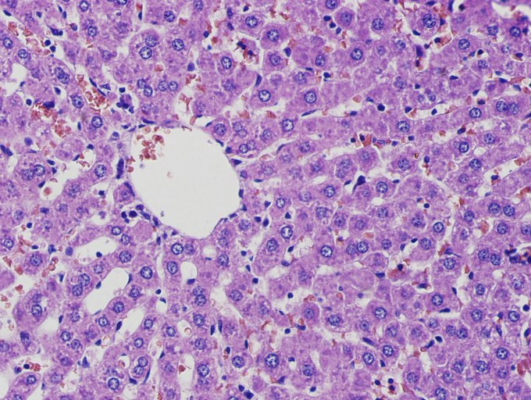
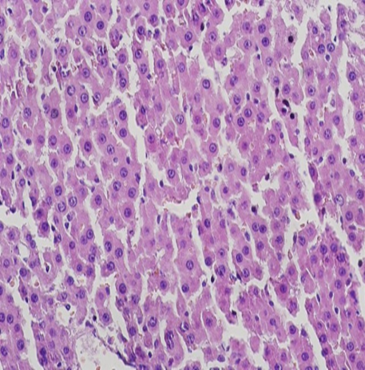
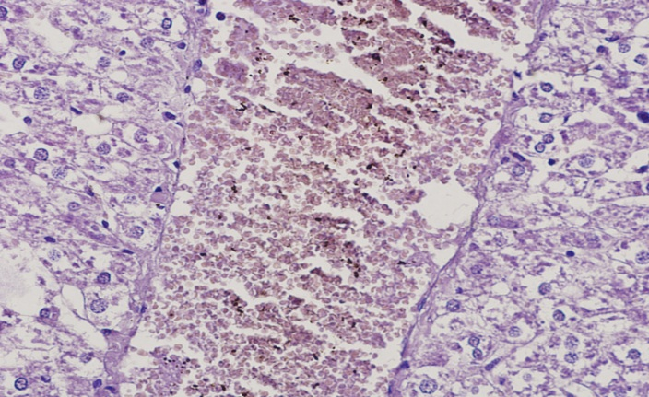
B
A
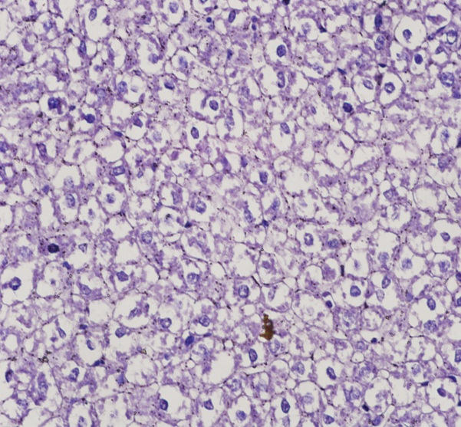
D
C
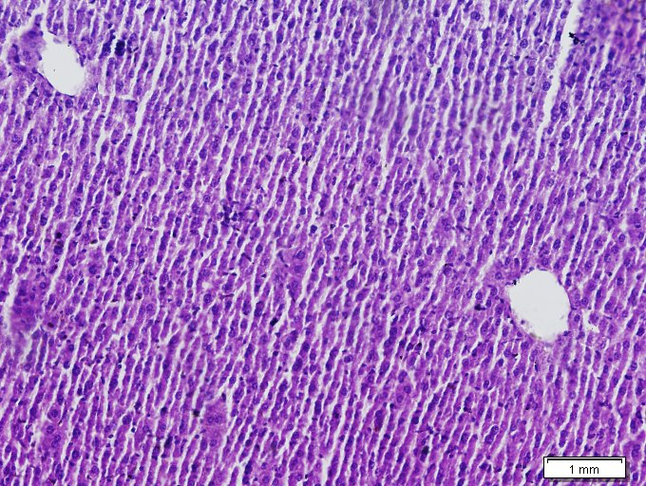

E

Figure 1: Histopathological study of liver tissue. Micophotograph of the liver tissue of the different treatment groups.
(A) Normal control (H&E.,X400 ) (B) Ibuprofen induced livertoxicity (H&E.,X400 ) (C) treated with Terfezia claveryi (H&E.,X400 ) (D) Ibuprofen+ Terfezia claveryi (H&E.,X 200) ( E) Terfezia claveryi + Ibuprofen (H&E.,X400 )

Discussion:

In this study we aimed to investigate the prophylactic and protective roles of Terfezia claveryi against Ibuprofen-induced oxidative stress in albino pregnant rats. This study evaluated liver function by assaying serum ALT, AST, ALP activities, and total bilirubin levels. In addition to that we evaluated oxidative stress in pregnant rats by assaying malondialdehyde (MDA) levels and glutathione peroxidase (GSH_{PX} ) ,Catalase (CAT), Superoxide Dismutase (SOD) activities.

Liver is one of the largest and vital important organ in the human body. It is play a very important roles in regulating homeostasis within the body by many functions, such as metabolism, secretion and storage. Liver damage caused by toxic chemicals and some drugs has been identified as a toxic problem. Hepatotoxicity is one of the most common factors leading to serious complications ranging from severe metabolic disorders to even fatalities. Most hepatic toxic chemicals infect liver cells mainly by stimulating lipid peroxidation (LPO) and other oxidative damage (30-33). Ibuprofen treatment causes significant increase in the serum activity of liver function tests such as (ALT),(AST),(ALP) and total bilirubin concentration as compared to control group, indicating hepatic dysfunction. These defects in liver functions may be due to the production of free radicals and involvement of oxidative stress (OS) to hepatic toxicity caused by Ibuprofen treatment. The results from this study confirmed that Ibuprofen at a dose of 40 mg/kg/day for 20 days produces significant hepatotoxicity as evidenced by increase in serum AST and ALT, ALP activity and total bilirubin concentration. The increase in liver function tests were well directly correlated with them liver histological damage. In the humans and in the experimental animals , ibuprofen (at high doses) is well known to be the cause of hepatotoxicity. In the liver Ibuprofen is metabolized to sulphate conjucates and extractable glucuronide. However, hepatotoxicity produced by ibuprofen may be due to formation of toxic metabolites. High doses of ibuprofen results to mitochondrial disorders followed by liver necrosis. All these changes mentioned above culminate in functional and morphological alterations resulting to loss of integrity of cell membranes which is manifested by the increase in the activity of serum marker enzymes ( ALT and AST activity).Transaminase were secreted to blood in hepatocellular damage and their levels increased (34) .This changes occurs because of hepatocyte damage due to the decreased activity of the antioxidant enzymes (SOD,CAT and and disturbance of calcium ( Ca²+) homeostasis(35). ALP is an enzymes derived from the liver and it is considered one of the liver function tests. It is plasma activity rise in cholestatic liver disorder because ALP synthesis is elevated and the enzyme within the biliary tract is regurgitated in to the blood (36). As compared to control groups, there was significant increase in serum bilirubin concentration in ibuprofen treated groups, and this increase may be linked to regurgitation of bile due to obstruction within the liver as a result of inflammation or injury caused by Ibuprofen. This results reported in this study are agree with other studies showing elevations of these parameters (AST, ALP ,ALT and total bilirubin ) in experimental animals exposed to Ibuprofen (20,35).However, administration of Terfezia claveryi along` with Ibuprofen ameliorated the histological alterations induced in the liver by Ibuprofen. Liver functions were also ameliorated as evidenced by significant restoration of serum AST, ALT, ALP activity and Bilirubin levels. According to these results, Janakat et al.,recorded that T. claveryi has a hepatoprotective effect on CCl4-induced liver toxicity in wister albino rats. Giving ibuprofen leads to a significant increase in liver content from MDA suggesting an increase in LPO that refers to oxidative stress (37) . LPO is one of the basic mechanisms of damage to liver tissue caused by free radicals (38).Moreover, Ibuprofen caused a significant reduction in SOD, CAT and GHPx activities. Antioxidants act as a radical tonic and inhibit LPO, thus protecting animal and human tissues from various diseases. There is a dynamic balance between the output of free radicals produced in the body and the antioxidant defense system that scavenges them and thereby protecting the human and animal body against pathogenesis. Antioxidant enzymes, such as SOD , GSH_{Px} and CAT are considered the first line of defense mechanism on free radical induced oxidative stress. SOD catalyzed the dismutation of the highly reactive superoxide anion to oxygen and to the less reactive species hydrogen peroxide (H₂O₂). H₂O₂can be destroyed by GP_{X} or CAT reactions (39-41) And CAT is responsible for the degradation of H2O2 to O2 and H₂O₂ . It is a protective antioxidant enzyme found in nearly all animal cells (42).A decrease in the activity of antioxidant enzymes and an increase in LPO level were reported after Ibuprofen intoxication (20,35). Damage of liver tissue seen in this study may be resulted from the increase in LPO level and decrease of antioxidant enzymes activity in the liver following exposure to Ibuprofen.

However, adminstration of Terfezia Claveryi along with Ibuprofen caused significant decrease in MDA levels and significant increase in CAT ,SOD and GSH_{Px} suggested the protective roles of Terfezia Claveryi .This protection offered by Terfezia Claveryi may be related to its free radical scavenging property. It is a very rich source of flavonoids which have been shown to possess different biological properties attributed to antioxidant mechanisms. Some studies recorded that the antioxidant capacity(AOC) of Terfezia Claveryi can be attributed to various chemical components of T. clveryi such as vitamin A, B-carotenoids, C and a large amount of phenolic compounds, which have an extremely strong antioxidant activity with high ability to search for peroxy roots, prevent cell membrane protrusions and reduce LOP (43). Thus, the protective effect of Terfezia Claveryi against Ibuprofen toxicity could be the result of direct free radical scavenger and antioxidant properties. There was significant decrease in serum AST, ALT, ALP activity, total bilirubin levels, in addition to that there was significant decrease in liver tissue MDA level and significant increase in liver tissue SOD,GX,CAT activity in Terfezia claveryi + Ibuprofen group as compared to Ibuprofen group. These results suggested that Terfezia claveryi and Ocimum basilicum has a prophylactic effect against liver toxicity caused by Ibuprofen.

We concluded , that addition of ibuprofen to pregnant rats increased LPO. Terfezia claveryi decreased the MDA levels in ibuprofen treated pregnant animals.Terfezia claveryi improved CAT,SOD and GSH_{PX} activities in liver tissues. We reported according to data application with Terfezia claveryi against oxidative injury in the liver which has the potential protective and prophylactic effect of Terfezia claveryi and can be said.

Acknowledgement:
The author are very much thankful to the College of Pharmacy, University of Kerbala / kerbala /Iraq for their constant help, encouragement and support to the research. At the same time we acknowledge Dr. Nezar metab from Hussein hospital teaching/kerbala/Iraq for histopathological examination.

References:

- Birben E, Sahiner UM, Sackesen C, Erzurum S, and Kalayci O, Oxidative Stress and Antioxidant Defense. WAO Journal 2012; 5:9–19.
- Zarkovic N, et.al. Oxidative Stress and Antioxidants: Biological Response Modifiers of Oxidative Homeostasis in Cancer. PERIODICUM BIOLOGORUM .2010 ; 112, 4: 433–439.
- Block G, Dietrich M, Norkus EP, Morrow JD, Hudes M, Caan B, Packer L. American journal of epidemiology. 2002; 156:274-285.
- Green GA. Understanding NSAIDs: from aspirin to COX-2. Clin Cornerstone. 2001;3:50–9.
- Burke A, Smyth EM, Fitzgerald GA. Analgesic-antipyretic agents; pharmacotherapy of gout. In: Brunton LL, Laxo JS, Parker KL, editors. Goodman & Gilman’s the pharmacologic basis of therapeutics. 11th ed. New York: McGraw-Hill; 2006.
- Bradbury F. How important is the role of the physician in the correct use of a drug? An observational cohort study in general practice, International Journal of Clinical Practice, Supplement, 2004; 144:27-32.
- Zoubair B, Azzahra LF, Fouzia H, Mohammed L, Brahim B and Noureddine B. Evaluation of Ibuprofen acid effect on oxidative stressed mice. Journal of Chemical and Pharmaceutical Research, 2016; 8(1):382-388.
- Stancova V, Plhalova L, Blahova J, Zivna D, Bartoskova M, Siroka Z, Marsalek P, Svobodova Z. Effects of the pharmaceutical contaminants ibuprofen, diclofenac, and carbamazepine alone, and in combination, on oxidative stress parameters in early life stages of tench (Tinca tinca). Veterinarni Medicina, 62, 2017 (02): 90–97.
- Higuchi K, Umegaki E, Watanabe T, Yoda Y, Morita E, Murano M, Tokioka S, Arakawa T. Present status and strategy of NSAIDs-induced small bowel injury, Journal of Gastroenterology, 2009; 44:879–88.
- Kalaivani B , Thangapandiyan K and Vanithakumari G. Alleviation of Ibuprofen induced Nephrotoxicity by vitamin supplementations. Int. J. of Life Sciences, 2016; 4 (2): 203-206.
- Walter H. Nonsteroidal Anti-Inflammatory Drugs and the KidneyPharmaceuticals 2010, 3, 2291-2321.
- Halawa HM , El-Nefiawy NE. EVALUATION OF MELATONIN EFFECT ON IBUPROFEN INDUCED RENAL AND TESTICULAR TOXICITY IN ADULT MALE ALBINO RATS.2017;2(5):1-18.
- Abatan MO, Lateef I, Taiwo VO. Toxic Effects of Non-Steroidal Anti-Inflammatory Agents in Rats. Afri J Biomed Res. 2006;9(3):219-23.
- CASARICA A et.al. A PURIFIED EXTRACT FROM BROWN TRUFFLES OF THE SPECIES TERFEZIA CLAVERYI CHATIN AND ITS ANTIMICROBIAL ACTIVITY. FARMACIA, 2016; 64: 2.
- Saddiq AA, Danial EN. Assessment of phenolic content, free radical-scavenging capacity and antimicrobial activities of Truffle claveryi. Wulfenia J 2012; 19: 403-422. (2012).
- Amna A. Saddiq JM. Youef AM.The Potential Antibacterial Role of Terfezia Claveryi Extract Against Immune-Inflammatory Disorder and Oxidative Damage Induced by Pseudomonas Aeruginosa in Rat Corneas. Romanian Biotechnological Letters. 2016; 21: 4.

- Janakat S, Al‐Fakhiri S, Sallal AK. Phytotherapy Research.2004; 18:810-813.
- Janakat S , Nassar M. Pakistan Journal of Nutrition.2010;9:52-56.
- Al-Laith AA, Antioxidant components and antioxidant/antiradical activities of desert truffle (Tirmania nivea) from various Middle Eastern origins. Journal of Food Composition and Analysis.2010;23: 15–22
- Jonah SA, Lucky LN, Cecilia NA. Evaluation of Toxicological Profile of Ibuprofen in Wistar Albino Rats. American Journal of Biomedical Sciences. 2014; 6: 32-40.
- Reitman S, Frankel S. A colorimetric method for the determination of serum glutamic oxaloacetic and glutamic pyruvic transaminase. Am J Clin.; 1957; 28:56-63.
- Kind PR, King EJ. Estimation of plasma phosphatase by determination of hydrolysed phenol with amino-antipyrine. J Clin Pathol,1954; 7, 322-326.
- Amour FF , Blood FR, Belden DA. The manual for laboratory work in mammalian Physiology. The University of Chicago Press, Chicago,1965 ;126-128.
- Lowry OH, Rosebrough NJ, Farr AL, Randall RJ. Protein measurements with the folin phenol reagent. The Journal of Biological Chemistry.; 1951;193: 265-75.
- Ohkawa H, Ohishi N, Yagi K. Assay for lipid peroxides in animal tissues by thiobarbituric acid reaction. Analytical Biochemistry.1979;95: 351-8.
- Worthington. V. Worthington Enzyme Manual, Lakewood, New Jersey.1975;5:20-21.
- Beers RF, Jrand IW. Journal of Biological Chemistry.; 1952; 195:133-140 .
- Flohéand L. Günzler WA .Methods in enzymology.1984;105: 114-120.
- Begum, NA, Dewan ZF, Nahar N,Mamun MI. Bangladesh Journal of Pharmacology.;2006,1,16-20.
- Ilango K. and Chitra V. Hepatproteactive and Antioxidant activities of Fruit Pulp of Limonia acidissima Linn. International Journal of Health Research. 2009; 2: 361‐367.
- Kanchanaa N. Mohamed Sadiq . Hepatoprotective effect of Plumbago Zeylanica on paracetamol induced liver toxicity in rats. International Journal of Pharmacy and Pharmaceutical Sciences. 2011; 3: 22-34.
- Patel RK, Patel MM, Patel MP, Kanzaria NR, Vaghela KR, Patel NJ. Hepatoprotective activity of Moringa oleifera Lam. Fruit on isolated rat hepatocytes. Phcog mag. 2008; 4:118‐123.
- Anitapal, Bhaskar B., Tanushree B., Manisha M., Kailash P. Hepatoprotective activity of Chenopodium Album Lbumlinn. Plant against paracetamol induced hepatic injury in rats. International Journal of Pharmacy and Pharmaceutical Sciences. 2011; 3: 3-15.
- Kalender S, Ogutcu A. Uzunhisarcikli M. Acikgoz F, Durak D, Ulusoy Y, Kalender Y. Diazinon-induced hepatotoxicity and protective effect of vitamin E on some biochemical indices and ultrastructural changes, Toxicol.2005;211:197-206.
- Jayavelu1 A, Natarajan S, Sundaresan K, Devi B. Hepatoprotective Activity of Boerhavia Diffusa Linn. (Nyctaginaceae) against Ibuprofen Induced Hepatotoxicity in Wistar Albino Rats. International Journal of Pharma Research & Review, April 2013; 2:1-8.
- . Das RN, Mukherjee S, Sharma I. Alkaline Phosphatase Determinants of Liver Patients. JOP. J Pancreas 2018; 30; 19(1):18-23.
- Li S et.al. The Role of Oxidative Stress and Antioxidants in Liver Diseases. Int. J. Mol. Sci. 2015;16: 26087–26124.
- Maityi T et.al. Hepatoprotective activity of mikania scandens (L.) WILD.Against diclofenac sodium induced liver toxicity in rats. Asian J Pharm Clin Res, 2012;5: 185-189.
- Anthony H. Kashou and Ashok Agarwal. Oxidants and Antioxidants in the Pathogenesis of HIV/AIDS. The Open Reproductive Science Journal, 2011, 3, 154-161.
- Bayazit H , Selek S , Karababa IF , Cicek E , Aksoy N. Evaluation of Oxidant/Antioxidant Status and Cytokine Levels in Patients with Cannabis Use Disorder. Clinical Psychopharmacology and Neuroscience 2017;15(3):237-242.
- Motor S et al. Evaluation of total antioxidant status, total oxidant status and oxidative stress index in patients with alopecia areata. Int J Clin Exp Med 2014;7(4):1089-1093.
- Zhou L , Feng J , Zhang L, Kuang Y. Clinical significance of serum total oxidant/antioxidant status for the disease activity in active rheumatoid arthritis. Int J Clin Exp Pathol 2017;10(8):8895-8900.
- Al-Laith AA. Antioxidant components and antioxidant/antiradical activities of desert truffle (Tirmania Nivea) from various Middle Eastern origins. J Food Compost Anal 2010; 23:15–22.

