Neuroprotective effects of onion (Allium cepa) ethanolic extract on animal model of Parkinson's disease induced by 6-hydroxydopamine: a behavioral, biochemical, and histological study
Mahmoud Salami¹, Omid Reza Tamtaji^{1,2}, Mojgan Mohammadifar², Sayyed Alireza Talaei¹, Abolfazl Azami Tameh³, Ali Reza Abed¹, Shahriar Shirkhoda¹, Ehsan Dadgostar⁴, Mohsen Taghizadeh⁵
¹ Physiology Research Center, Kashan University of Medical Sciences, Kashan, I.R. Iran
² Research Center for Biochemistry and Nutrition in Metabolic Diseases, Kashan University of Medical Sciences, Kashan, I.R. Iran
³ Anatomical Sciences Research Center, Kashan University of Medical Sciences, Kashan, I.R. Iran
⁴ Halal Research Center of IRI, FDA, Tehran, I.R. Iran
⁵ Student Research committee, Kashan University of Medical Sciences, Kashan, I.R. Iran

Running Title: Effects of onion on Parkinson disease
* Corresponding Author: Mohsen Taghizadeh, Address: Research Center for Biochemistry and Nutrition in Metabolic Diseases, Kashan University of Medical Sciences, Kashan, I.R. Iran, Qotbe Ravandi Blvd., Kashan, Iran
Email: mohsenta44@yahoo.com Phone: +98 9133633213 Fax: +98 31 55621157
Number of words (Text): 1891
Number of words (Abstract): 250
Number of Figures: 5
Abstract
Objectives: Parkinson’s disease (PD), a progressive neurodegenerative disorder. Oxidative stress plays an important role in PD pathophysiology. Onion has antioxidant properties. In an experimental study, we have evaluated the effects of onion ethanolic extract (OEE) on animal models of Parkinson disease (PD) in male rats.

Methods: Studied groups were sham group, Parkinson’s group (Parkinson rats without treatment), and three treatment groups including Parkinson rats that treated with OEE at 50, 100, and 200 mg/kg/day. Animal model of PD was induced by injection of 6-hydroxydopamine (6-OHDA) into the right substantia nigra. The administration of all the extracts were started 14 days before the surgery and continued daily for seven days after surgery. Learning and memory were evaluated by a Morris water maze. In addition, malondialdehyde (MDA) concentrations and histological parameters (density of neurons) were determined by thiobarbituric acid reactive substances (TBARS) and Nissl staining, respectively.
.Results: Our results showed that 6-OHDA led to cognitive dysfunction, increased MDA and neuronal damage compared sham group. However, the administration of OEE was improved cognitive dysfunction, decreased MDA and prevented neuronal damage in animal model of PD.
Conclusion: The onion could be a new nutrition strategy and essential part of the food diet for preventing PD.
Keywords: Onion; learning; memory; Parkinson disease

Introduction
Parkinson’s disease (PD), a progressive neurodegenerative disorder, is common in the population over 60 years of age [1]. Dopaminergic neuron degeneration in substantia nigra pars compacta (SNpc) occurs in PD which is related to clinical manifestation of PD [2]. Clinical symptoms include hypokinesia, tremor, cognitive dysfunction and depression [1]. PD is a disease with multifactorial etiology [3, 4]. It has been reported that inflammatory factors [5], immunological changes [6] and oxidative stress such as increased malondialdehyde (MDA) play an important role in PD pathophysiology [7, 8]. Levodopa is known as the routine drug in treatment of PD [9]. However, long-term treatment with LD is associated motor complications[10].
Some studies have shown that the supplements [11] and medical plants [12, 13] may benefit the improvement of clinical symptom in PD and other neurodegenerative disorders. Onion (A. cepa L.) as a plant belongs to the genus Allium. Onion is classified into red, yellow and white. Onion has high consumption and is known as essential components of dietary foods [14].
It is reported that it has improver effects on neurological disorders. Shir et al. [15] found that administration of onion significantly improved the learning and memory performances in animal model of ischemia. In our previous study, we found that onion extract corrected cognitive dysfunction in animal model of diabetes [16]. Other vegetables belonging to the Allium family have also indicated their beneficial effects on learning and memory abilities [17]. They contain a high amount of flavonoid compounds such as quercetin, kaempferol, and gallic acid which the antioxidant properties of onion may be due to the presence of these compounds [18]. The antioxidant activities of onion can lead to the inhibition of apoptosis pathways and protection of neuronal damage [19].
In the present work we aimed to assess if prescribe onion ethanolic extract orally influences learning and memory, as well as biochemical and histological changes in animal model of PD.

Materials and Methods
Study design
Our experimental study was performed in physiology research center of Kashan University of Medical Sciences (KAUMS). After preparing the extract, it was administrated orally for two weeks. Then, induction of PD model was performed in male rats by injection of 6-hydroxydopamine (6-OHDA). Finally, assessment of learning and memory, histological changes and oxidative stress were done after seven days after 6-OHDA injection.
Preparation of extract of onion
Red onion was procured from Research farm of the Medicinal Plant Research Center, Barij (Kashan, Iran). The voucher specimens were identified and deposited in the Herbarium of the Department of Agriculture, Medicinal Plants Research Center, Barij, Kashan Iran. After washing with water, these were cut into small pieces and dried. Then, the dried onions were crushed. The powder was mixed with ethanol (70%) for 72 hours at the ambient temperature in the percolator. The extract was separated and placed in a sterile container. The extract was concentrated under reduced pressure in a rotary evaporator at 30⁰C to 40⁰C [20].
Animals
Male Wistar rats were purchased from Kashan University of Medical Sciences. The rats were maintained with a 12:12 hour light-dark cycle at 25 ± 5°C and 55% ± 10% humidity. The diet and water were given ad libitum. This study was approved by the research ethics committee of Kashan University of Medical Sciences (KUMS), Kashan, Iran. The animals were divided into five groups (n = 10): Sham group (received 2μL of 0.2% saline with ascorbic acid), Parkinson’s group (6 μg of 6-OHDA in 2 μL 0.2% saline with ascorbic acid) and three treatment groups (received 6 μg of 6-OHDA in 2 μL 0.2% saline with ascorbic acid plus ethanolic extract of onion at 50, 100 and 200 mg/kg/day). All extracts and distilled water administrated orally for 14 days before and 7 days after the injection of 6-OHDA.
Experimental Protocol Used for the 6-OHDA Model of PD
The animals were anaesthetized intraperitoneally (IP) by xylazine (10mg/kg, IP) and ketamine (100 mg/kg, IP) and fixed to a stereotaxic apparatus. 6-OHDA (6 μg of 6-OHDA in 2 μL 0.2% saline with ascorbic acid) was injected by an injection needle attached to a microsyringe unilaterally into the SNpc. The injection coordinates were: anterior/posterior: −5.3 mm; medial/lateral: +2.2 mm; ventral/dorsal: −7.8 mm. The animals returned to their cages for recovering.

Behavioral Testing
Morris water maze

The spatial learning and memory were assessed by Morris water maze as described previously [21, 22]. A black circular water pool was used for the water maze test. It was 180 cm in diameter × 60 cm in depth. A black escape platform was submerged 1 cm below the water in one of the four imaginary quadrants. The animals were released into the water at one of four positions (N, S, E and W) that was predetermined randomly by a computer equipped with water maze software (Radiab 7, IR Iran). The escape latency on the platform was measured for assessment of the learning process. On the fifth day (probe test), the platform was removed and the rats were released randomly in one of the positions into the water and allowed to swim for 30 seconds. The time passed in the critical quadrant was measured for assessment of consolidation of spatial memory.

Biochemical study

The hippocampus and midbrain of the lesion side were isolated and homogenized to assess the MDA concentration by thiobarbituric acid reactive substances (TBARS) [23].

Histological study
Following anesthesia with chloral hydrate (0.5 ml/100 g), the brain fixation was performed by neutral-buffered formalin fixative solution (NBF 10%, pH value = 7.4). The brains were removed and stored in the same solution at 4°C overnight. The brains were transferred into a tissue processor for 17.5 hours. Finally, the specimens were frozen rapidly and coronal sections 5 μm thick were prepared using cryostat. Cresyl violet (Nissl) staining was performed for assessment of the extent of histological lesion in the SNpc and CA1 of hippocampus. The coronal sections of brains were stained with 1% cresyl violet, dehydrated in graded series of ethanol, immersed in xylene and mounted on Entellan. Finally, the intact cells (percentage of total) were evaluated.
Statistical Analyses
The data from the training phase of the Morris water maze were analyzed using repeated measures analysis of variance (ANOVA). Two-way ANOVA was applied to the values obtained from the probe trials, MDA concentration and cell counting. Bonferroni post hoc test was also used on the significant data. The threshold of significance was regarded as P<0.05.

Results

The effects of onion extract on learning and memory

The data from Morris water maze showed a general significant difference between the all groups (F4, 155=8.538; P < 0.0001). Injection of 6-OHDA decreased the learning process in the PD group, which displayed the worst behavior in learning the task (P < 0.0001, compared with the SH group). The administration of onion at 100 and 200 mg/kg significantly improved the learning process (P = 0.009 and P = 0.001, respectively) so that the ethanolic extract of onion groups revealed a learning ability close to the sham group (P = 0.418 and P = 1, respectively) (Figure 1).
Also, our data related to memory consolidation showed a general significant statistical difference among all groups (F4, 34 = 5.708; P < 0.05). Injection of 6-OHDA further decreased the memory consolidation in comparison with the sham group (P = 0.03). The administration of onion at 100 and 200 mg/kg significantly improved the memory consolidation compared with the sham group (P = 0.013 and P = 0.045, respectively) (Figure 2).
The effects of onion extract on MDA concentrations
Our data showed that injection of 6-OHDA significantly increased the level of MDA in the hippocampus and midbrain of PD animals compared with the sham group (P < 0.05). Administration of onion extract reduced MDA levels in all treatment groups (P < 0.05) (Figure 3).
The effects of onion extract on density of neurons

The degree of neuronal damage in SNpc and CA1 was evaluated by Nissl staining. In the sham group, SNpc and CA1 neurons appeared unaffected and showed round and pale-stained nuclei. In contrast, many neurons in the PD group showed an aberrant morphology with shrunken cell bodies, chromosome condensation and nuclear pyknosis. The administration of onion extract reduced the number of degenerating neurons and significantly preserved the intact structure of neurons (p < 0.0001) (Figures 4 A and B).

Discussion
We evaluated the effects of the administration of ethanolic extract of onion on learning and memory abilities, histological changes and brain MDA in animal model of PD induced by 6-OHDA. Our results showed that administration of onion reversed learning and memory deficits in PD rats. To the best of our knowledge, the current study is the first to report the effects of administration of onion on PD. The beneficial effects of onion on the nervous system were seen in other behavioral studies. For example, Shir et al. [15] found that administration of onion significantly improved learning and memory performances in animal model of ischemia. In our previous study, we found that onion extract corrected cognitive dysfunction in animal model of diabetes [16]. The Liliaceae family includes onion and garlic [24]. Garlic also has beneficial effects on the functioning of the nervous system. In a study by Haider et al. [25], a significantly increased memory capacity was observed following the administration of garlic extract. In addition, diabetic rats treated with garlic extract demonstrated reversing of memory impairment [26].

Oxidative stress, an imbalance between the production of reactive oxygen species and the activities of antioxidant scavenging, is caused by the induction of PD through the injection of 6-OHDA in rodents. This mechanism has a critical role in cognitive dysfunction [27]. The current study demonstrates that the administration of onion ethanolic extract significantly decreases MDA in the brain. Similar to the findings of the current study, Hyun et al. [28] found that the administration of onion extract significantly increased the antioxidant capacity in ischemic mice. In addition, onion reduced MDA in rats with cardiac ischemia [29]. Onion is rich in flavonoid and polyphenol compounds, including quercetin and rutin [30], which may act as scavengers of oxidative stress [31, 32]. In addition, previous studies have shown that the flavonoid and phenolic compounds in onion may result in reduced cell apoptosis or neuronal death by the inhibition of c-Jun N-terminal kinases (JNKs) pathways following the control of oxidative stress [33].
Our histological study confirmed the behavioral results in which the number of neurons in the SNpc and CA1 were decreased in the animals with PD. Lower decrease was, however, seen in the number of neurons in the onion-treated groups. Hwang et al. found that the administration of onion and quercetin significantly prevented the neuronal damage of CA1 in the animal model of ischemia [19]. In another study, onion and quercetin decreased neuronal death by the inhibition of oxidative stress [34]. The administration of quercetin also reduced neuronal damage in the different regions of the hippocampus in PD rats [35]. It seems, through controlling the oxidative stress, the onion extract treatment may prevent neuronal death in different area of brain specially SNpc and CA1 in PD rats.
The current study did, however, have certain limitations. Owing to budgetary constraints, we could not assess the beneficial effects of onion on inflammatory cytokines and apoptosis as well as phytochemical analysis of extract.

Conclusion
Our findings show that the administration of onion ethanolic extract in animal models of PD has beneficial effects on learning, memory, MDA, and histological parameters. The onion could be a new nutrition strategy and essential part of the food diet for preventing PD.

Acknowledgements
The present study was supported by a grant No.93059 from the Vice Chancellor for Research, Kashan University of Medical Sciences (KUMS), Iran.

Declaration of Interest
The authors declare no conflict of interest.
Author contributions
MT and MS contributed in the conception or design of the work, analysis and drafting of the manuscript. O-RT, MM, S-AT, AA, AA, SS and ED contributed in conception and manuscript drafting. The final version was confirmed by all authors for submission.

References
1. Jankovic, J., Parkinson’s disease: clinical features and diagnosis. Journal of Neurology, Neurosurgery & Psychiatry, 2008. 79(4): p. 368-376.
2. Skaper, S.D., The brain as a target for inflammatory processes and neuroprotective strategies. Annals of the New York Academy of Sciences, 2007. 1122(1): p. 23-34.
3. Fan, T.S., et al., Lack of TMEM230 mutations in patients with familial and sporadic Parkinson's disease in a Taiwanese population. American Journal of Medical Genetics Part B: Neuropsychiatric Genetics, 2017.
4. Nandipati, S. and I. Litvan, Environmental exposures and Parkinson’s disease. International journal of environmental research and public health, 2016. 13(9): p. 881.
5. Kouchaki, E., et al., Increased serum levels of TNF-α and decreased serum levels of IL-27 in patients with Parkinson disease and their correlation with disease severity. Clinical neurology and neurosurgery, 2018. 166: p. 76-79.
6. Kouchaki, E., et al., Correlation of serum levels and gene expression of tumor necrosis factor-α-induced protein-8 like-2 with Parkinson disease severity. Metabolic brain disease, 2018. 33(6): p. 1955-1959.
7. Chen, C.-M., et al., Increased oxidative damage in peripheral blood correlates with severity of Parkinson's disease. Neurobiology of disease, 2009. 33(3): p. 429-435.
8. Mansouri, M.T., et al., Neuroprotective effects of oral gallic acid against oxidative stress induced by 6-hydroxydopamine in rats. Food chemistry, 2013. 138(2): p. 1028-1033.
9. Olanow, C.W., et al., Levodopa in the treatment of Parkinson's disease: current controversies. Movement Disorders, 2004. 19(9): p. 997-1005.
10. Aquino, C.C. and S.H. Fox, Clinical spectrum of levodopa‐induced complications. Movement Disorders, 2015. 30(1): p. 80-89.
11. Weber, C.A. and M.E. Ernst, Antioxidants, supplements, and Parkinson's disease. Annals of Pharmacotherapy, 2006. 40(5): p. 935-938.
12. Kim, M.S., et al., Neuroprotective effect of Ginkgo biloba L. extract in a rat model of Parkinson's disease. Phytotherapy Research, 2004. 18(8): p. 663-666.
13. Zeng, G.-f., et al., Protective effects of ginger root extract on Alzheimer disease-induced behavioral dysfunction in rats. Rejuvenation research, 2013. 16(2): p. 124-133.
14. Siracusa, L., et al., Re‐evaluation of traditional Mediterranean foods. The local landraces of ‘Cipolla di Giarratana’(Allium cepa L.) and long‐storage tomato (Lycopersicon esculentum L.): quality traits and polyphenol content. Journal of the Science of Food and Agriculture, 2013. 93(14): p. 3512-3519.
15. Shri, R. and K.S. Bora, Neuroprotective effect of methanolic extracts of Allium cepa on ischemia and reperfusion-induced cerebral injury. Fitoterapia, 2008. 79(2): p. 86-96.
16. Tamtaji, O.R., et al., Protective Effects of Red Onion (Allium cepa) Ethanolic Extract on Learning and Memory Impairments in Animal Models of Diabetes. Galen Medical Journal, 2017. 6(3): p. 249-257.
17. Mukherjee, D. and S. Banerjee, Learning and memory promoting effects of crude garlic extract. 2013.
18. Albishi, T., et al., Antioxidative phenolic constituents of skins of onion varieties and their activities. Journal of Functional Foods, 2013. 5(3): p. 1191-1203.
19. Hwang, I.K., et al., Neuroprotective effects of onion extract and quercetin against ischemic neuronal damage in the gerbil hippocampus. Journal of medicinal food, 2009. 12(5): p. 990-995.
20. Tamtaji, O.R., et al., Effect of alcoholic extract of Iranian red onion on diabetic neuropathic pain in streptozotocin-diabetic rats. Physiology and Pharmacology, 2014. 18(4): p. 466-476.
21. Mahboubi, M., et al., Combined Administration of Melissa officinalis and Boswellia serrata Extracts in an Animal Model of Memory. Iranian journal of psychiatry and behavioral sciences, 2016. 10(3).
22. Morris, R., Developments of a water-maze procedure for studying spatial learning in the rat. Journal of neuroscience methods, 1984. 11(1): p. 47-60.
23. Chen, Y., et al., Anti-oxidant polydatin (piceid) protects against substantia nigral motor degeneration in multiple rodent models of Parkinson’s disease. Molecular neurodegeneration, 2015. 10(1): p. 4.
24. Kemper, K.J., Garlic (Allium sativum). The Longwood Herbal Task Force and the Center for Holistic Pediatric Education and Research, 2000: p. 49.
25. Haider, S., et al., Repeated administration of fresh garlic increases memory retention in rats. Journal of medicinal food, 2008. 11(4): p. 675-679.
26. Sarkaki, A., et al., Effects of fresh, aged and cooked garlic extracts on short-and long-term memory in diabetic rats. Avicenna journal of phytomedicine, 2013. 3(1): p. 45.
27. Hritcu, L., A. Ciobica, and V. Artenie, Effects of right-unilateral 6-hydroxydopamine infusion-induced memory impairment and oxidative stress: relevance for Parkinson’s disease. Open Life Sciences, 2008. 3(3): p. 250-257.
28. Hyun, S.-W., et al., Onion (Allium cepa) extract attenuates brain edema. Nutrition, 2013. 29(1): p. 244-249.
29. Park, S., et al., Methanolic extract of onion (Allium cepa) attenuates ischemia/hypoxia-induced apoptosis in cardiomyocytes via antioxidant effect. European journal of nutrition, 2009. 48(4): p. 235-242.
30. Machavarapu, M., K. Manoj, and V. Meena, Optimization of Physico-chemical Parameters for the Extraction of Flavonoids and Phenolic Components from the Skin of Allium cepa. International Journal of Innovative Research in Science, Engineering and Technology, 2013. 2(7): p. 3125-3129.
31. Coskun, O., et al., Quercetin, a flavonoid antioxidant, prevents and protects streptozotocin-induced oxidative stress and β-cell damage in rat pancreas. Pharmacological research, 2005. 51(2): p. 117-123.
32. López-Revuelta, A., et al., Membrane cholesterol contents influence the protective effects of quercetin and rutin in erythrocytes damaged by oxidative stress. Chemico-biological interactions, 2006. 161(1): p. 79-91.
33. Ishikawa, Y. and M. Kitamura, Anti-apoptotic effect of quercetin: intervention in the JNK-and ERK-mediated apoptotic pathways. Kidney international, 2000. 58(3): p. 1078-1087.
34. Lee, B.K. and Y.-S. Jung, Allium cepa extract and quercetin protect neuronal cells from oxidative stress via PKC-ε inactivation/ERK1/2 activation. Oxidative medicine and cellular longevity, 2016. 2016.
35. Sriraksa, N., et al., Cognitive-enhancing effect of quercetin in a rat model of Parkinson's disease induced by 6-hydroxydopamine. Evidence-Based Complementary and Alternative Medicine, 2011. 2012.

Figure Legends

Figure 1. Effects of ethanolic extract of onion on latency to escape in Morris water-maze. The data are expressed as Mean ± SEM. The significance was determined by the two-way repeated measures analysis of variance (ANOVA) followed by the Bonferroni post hoc test (n = 10).
OE: Onion extract, PD: Parkinson’s disease, SH: Sham

Figure 2. Effects of ethanolic extract of onion on the time elapsed by the rats in the correct quadrant in the probe trial test. The data are expressed as Mean ± SEM. The significance was determined by one-way ANOVA, followed by the Bonferroni post hoc test: * The difference between PD and other groups: P < 0.05 (n = 10).
OE: Onion extract, PD: Parkinson’s disease, SH: Sham

Figure 3. Effects of ethanolic extract of onion on the MDA concentration in the midbrain and the hippocampus. The data are expressed as Mean ± SEM. Significance was determined by the one-way ANOVA test followed by the Bonferroni post hoc test: * Difference between PD and other groups: P < 0.05 (n = 6).

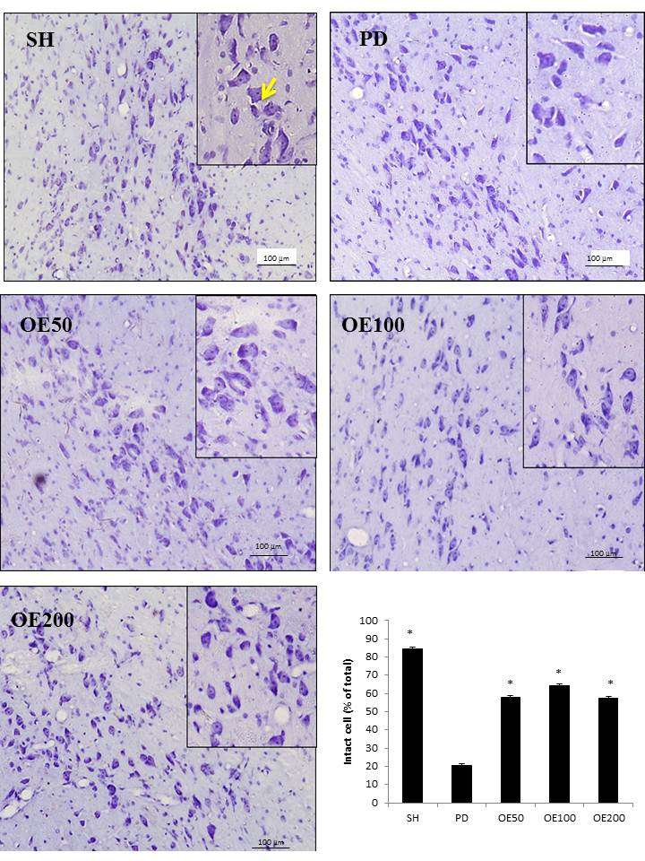
Figure 4A. Effect of onion extract on neuronal damage in SNpc of the animal model of PD. The administration of onion extract decreased the neuron loss induced by 6-OHDA. The numbers of surviving neurons in the SNpc are given as a percentage of the total cells (* P < 0.05 vs. PD group, n=4).

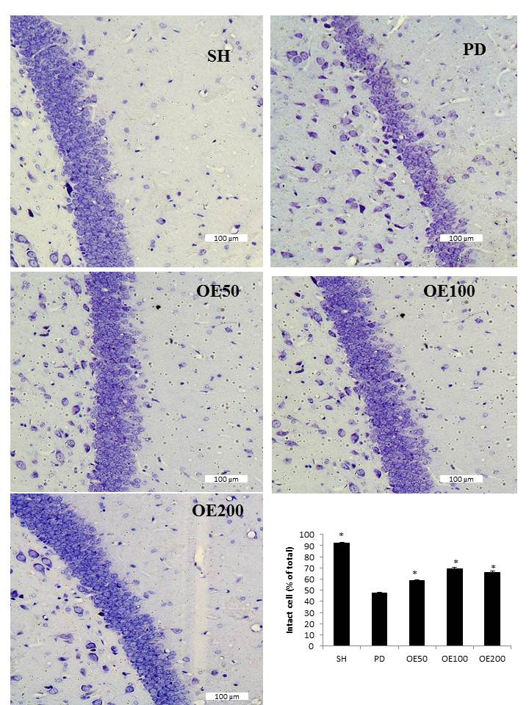
Figure 4B. Effect of onion extract on neuronal damage in the CA1 of the animal model of PD. Administration of onion extract decreased the neuron loss induced by 6-OHDA. The numbers of surviving neurons in the CA1 are given as a percentage of the total cells (* P < 0.05 vs. PD group, n=4).

