Image 1

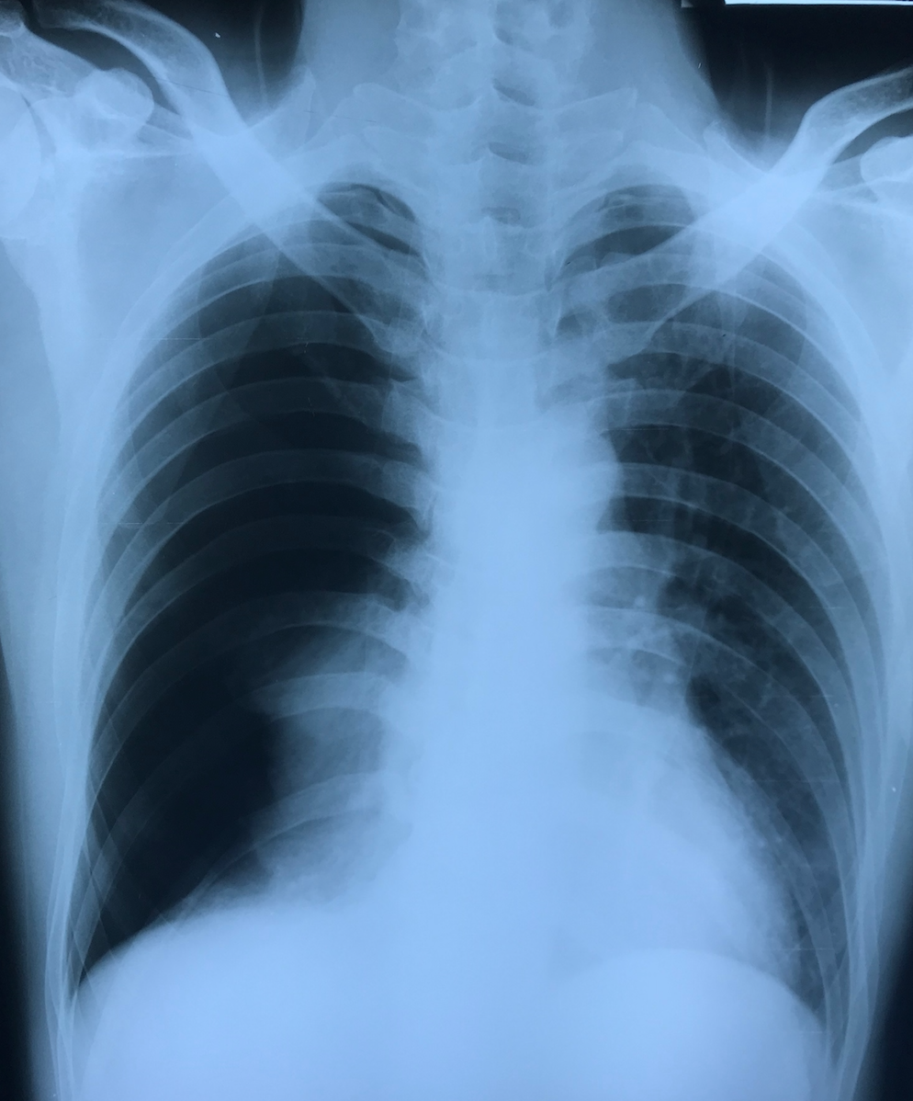

Image 2

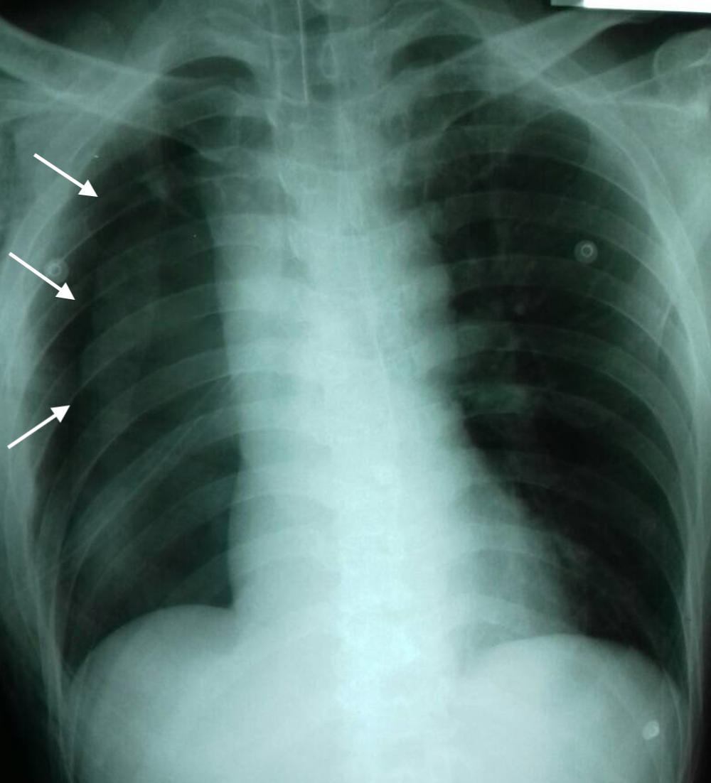

Image 3

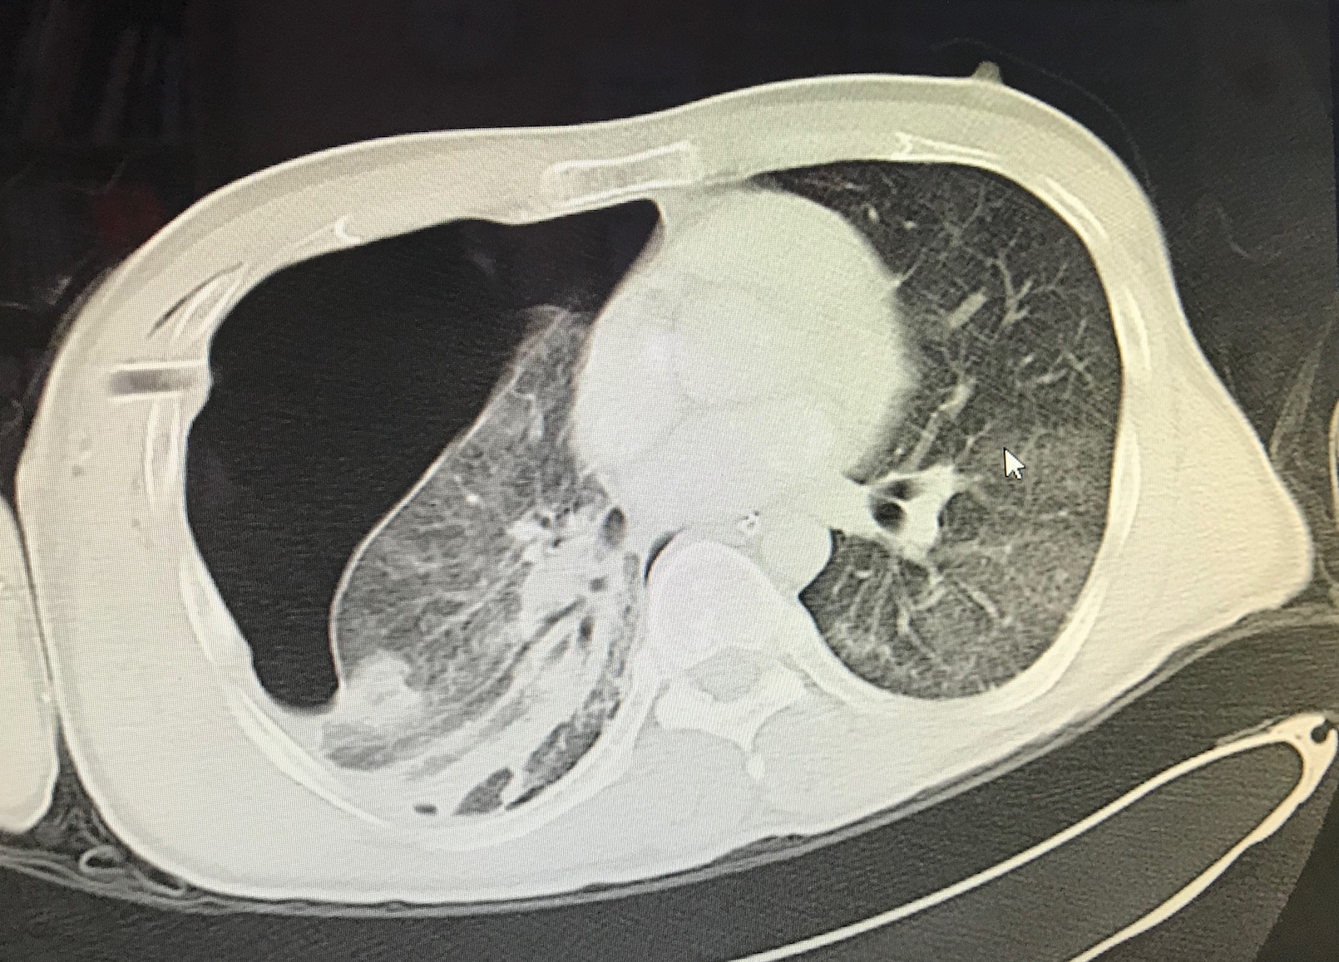

Image 4

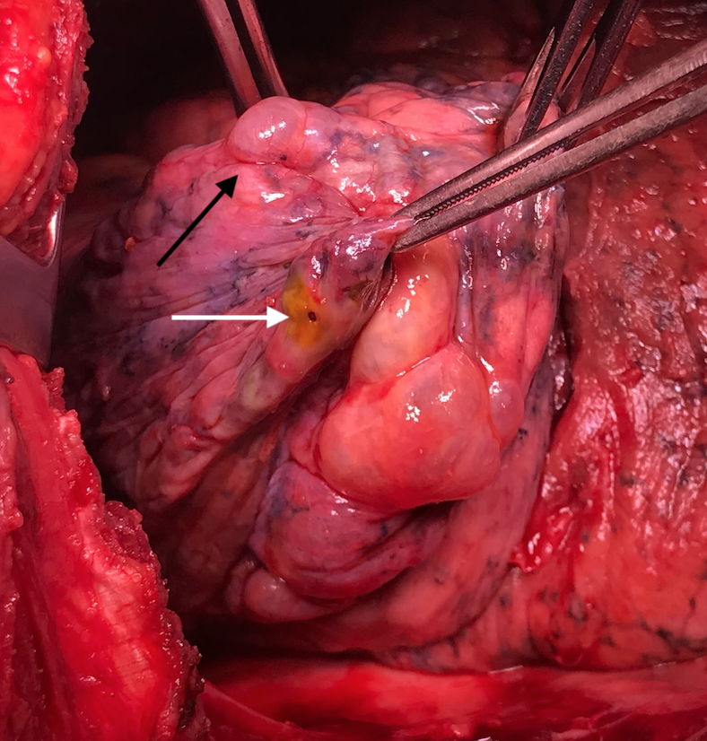

Figure legend

Image 1: Right pneumothorax evidence by hyperluscent right lung

Image 2: Chest tube in situ with presence of pleural line (white arrow)

Image 3: Computed tomography of thorax revealed a large right pneumothorax and presence of bullae and bleb

Image 4: Intraoperative findings during open thoracotomy revealed presence of a small puncture wound at the lung parenchyma (white arrow) and bullae (black arrow)

