SURGICAL MANAGEMENT OF A SPONTANEOUS BLACK TENDON RUPTURE
ABSTRACT:
Spontaneous non-traumatic rupture of Tendo-Achilles (TA) as a presenting feature of alkaptonuria is unusual. In this disorder, the deposition of homogentisic acid in the cartilage of major joints and intervertebral disc is responsible for the degenerative changes, besides excretion of dark urine. Infrequently, it also gets deposited in major tendons that renders them structurally weak ensuing in pathological ruptures. A case is presented with non-traumatic TA rupture in absence of other typical clinical features of alkaptonuria.
Keywords: tendoachilles; alkaptonuria; spontaneous; rupture; repair
INRODUCTION:
Non-traumatic spontaneous rupture of a tendon should lead to suspicion of a pathological tear and subsequently it should be thoroughly evaluated. Alkaptonuria is a rare form of in born error of metabolism of amino acids (phenylalanine and tyrosine), in which urine turns black due to presence of excess of Homogentisic Acid (HA) (1). This breakdown product also gets deposited in various soft tissues like cartilage, ligaments, intervertebral discs, bones and heart valves (Ochronosis). This clinically translates to a triad of urine turning dark upon contact with air, soft tissue pigmentation and secondary degenerative arthritis. The deposition of HA in the Tendo-Achilles (TA) and subsequent rupture is an unusual incident. There is paucity of cases describing such an event and outcomes after surgical management in the literature. We report an unusual case of spontaneous rupture of TA as an initial presentation of alkaptonuria in absence of other classical features of the condition.

CASE:
An apparently healthy 35 years old male presented to our foot and ankle clinic with pain in the left ankle and difficulty in walking since twenty days. Twenty days back while getting down a bus he felt a sharp pain in his left ankle. After some time, he continued to walk with pain and experienced some difficulty in movements at the left ankle. There was no similar complaints in the past. There was no significant medical and family history. General examination was unremarkable. On local examination, there was palpable defect noted in the TA about 3-4cms from its insertion. There was decreased power of plantar flexion of the left ankle as compared to the opposite side. However, Thompson’s test for a ruptured TA was negative. An MRI study of the left ankle revealed a partial thickness intra-substance tear of TA in the distal fibres with retraction of fibres proximally from insertion site, suggestive of a Type I TA tear [figure 1]. Surgical management was considered in view of clinical suspicion of a pathological rupture.
Figure 1: MRI T1 weighted sagittal view showing partial rupture of TendoAchilles (Arrow pointing the rupture site)
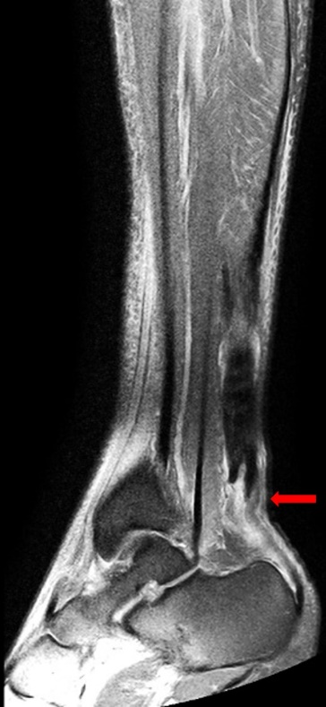
Under spinal anaesthesia and tourniquet control, patient was placed in prone position. A 10cms midline linear incision was made over the posterior aspect of ankle. On exposure, the distal end of proximal torn part (for about 2cms) of the tendon appeared blackened [figure 2].
Figure 2: Intra-operative image showing the blackened region in the proximal part of the ruptured tendon.
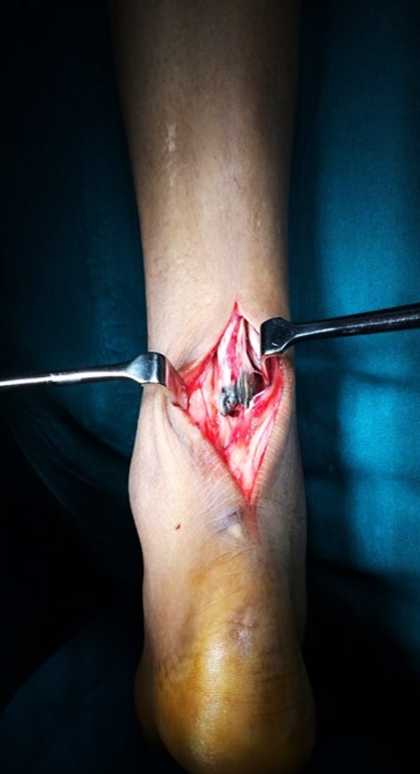
Rest of the tendon on either sides appeared normal in appearance and texture. On palpation, a grating sensation of this segment was appreciated. This pathological segment was excised and sent for histopathological examination. The two ends were repaired together by Krackow suture technique using high strength Orthocord sutures. Paratenon was repaired with 3-0 vicryl and patient was shifted out in above knee slab with knee in 20⁰ flexion and ankle in 20⁰ plantar flexion. This position was maintained for a period of three weeks in an above knee cast and later converted to below knee cast for another three weeks period. Patient was mobilised non-weight bearing with support for six weeks followed by gradual partial weight bearing as tolerated. Follow-up at sixteen months his American Foot and Ankle score is 97.
Post-operatively, patient gave history of passing dark urine (figure 3) and in childhood he and his brother had history of staining the diapers with dark urine, however, no further investigations or treatments were pursued. His urine examination for HA was strongly positive.
Figure 3: Urine turns dark on exposure to air
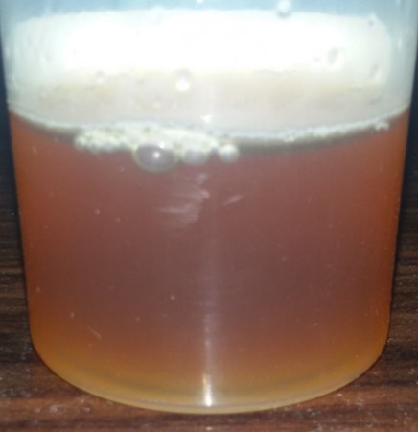
Histopathology suggested features of calcific tendinitis. His liver function tests, renal function tests, ECG, Echocardiography and skeletal survey were all essentially normal.
DISCUSSION:
Alkaptonuria is a rare autosomal recessive disorder that occurs due to deficiency of an oxidase enzyme necessary for the metabolism of HA. The incidence of this condition is reported to be 1 in 250000 to 1 in 1000000 live births (2), however there is no Indian subcontinent data available.
In childhood, apart from urine turning black from exposure, no other symptoms will be presented. Patient and his brother reported to have a childhood history of dark staining of the diapers. Urinary and plasma HA levels can be measured using spectrophotometric and chromatographic method.
Joint pains usually begin in the adulthood and weight bearing joints are frequently affected. Radiographic screening of the spine and pelvis is useful to determine the onset of ochronotic arthropathy. In our patient, the disc spaces were maintained and there were no abnormal calcification, osteopenia or degenerative changes observed [Figure 4].
Figure 4: X-ray of cervical (A & B) and thoracolumbar (C & D) spine (anteroposterior and lateral views) and pelvis (E) which were essentially normal
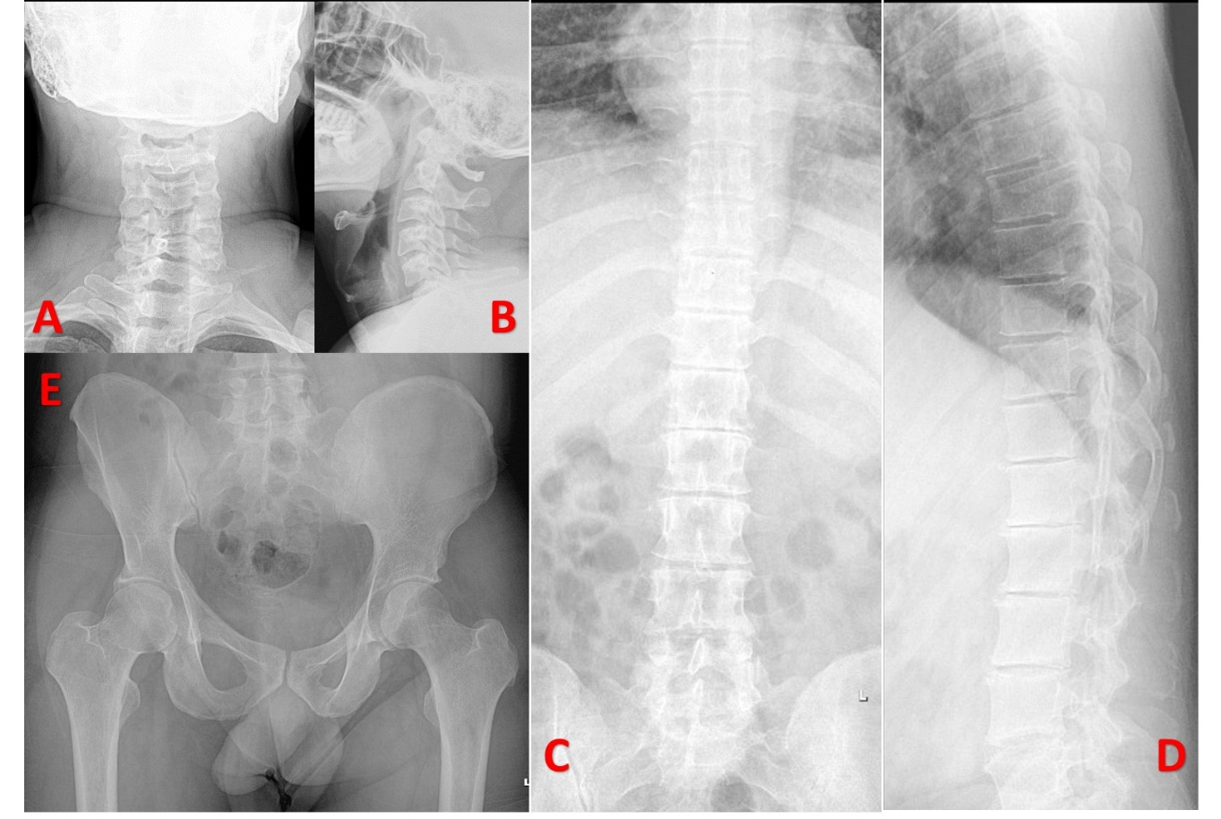
The facet joints and the sacro-iliac joints were also uninvolved. Similarly, other peripheral joints were essentially normal. By the fourth or fifth decade the disease usually progresses from simple alkaptonuria to alkaptonuric arthropathy in approximately 30% of subjects (3).
Scleral pigmentation (Osler sign) and pigmentation of the ear cartilages are also frequently seen sometime around 3rd decade. Furthermore, discoloration of the forehead, axilla, groin, teeth, palms, and soles and dark staining of the nails can also be seen. However, none of these signs were present in our patient [Figure 5]. Cardiac involvement is usually seen in the form of mitral or aortic valve calcification or regurgitation which needs to be screened by echocardiography.
Figure 5: Clinical image of patient’s eyes (A), ears (B) and nails (C) showing absence of typical pigmentations.
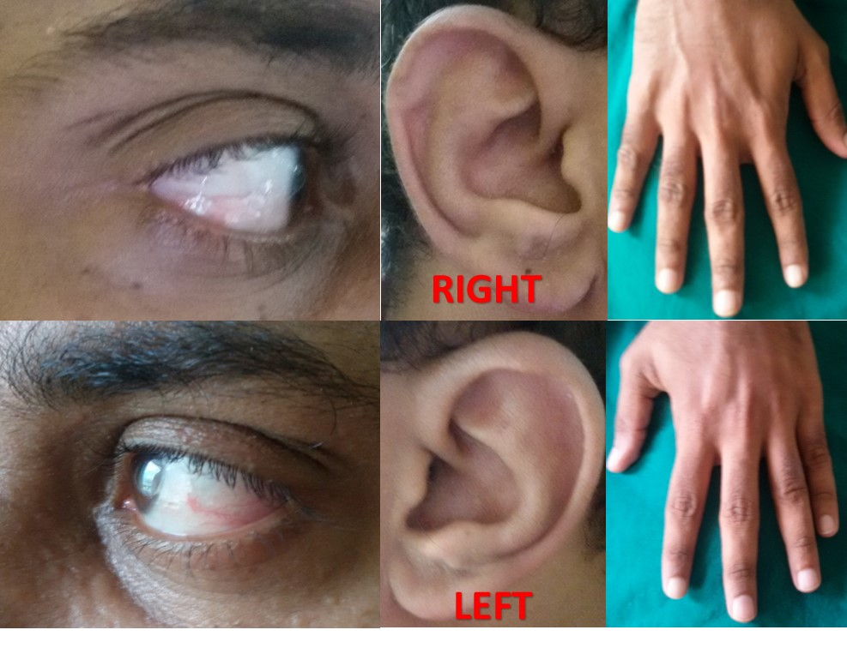
Pathological or spontaneous rupture of tendons due to the deposition of HA in the substance of tendons are extremely rare presentation. Large tendons such as quadriceps tendon and TA can be frequently involved, especially at the site of insertion. The accumulation of HA inhibits collagen cross-linking, leading to a reduction in the structural integrity of collagen, and thus increasing the likelihood of spontaneous rupture (4).
The diagnosis of TA rupture can be comfortably made based upon clinical examination. This can be further confirmed by either Ultrasonography or Magnetic Resonance Imaging studies. There are four types of TA injuries (5). Accordingly, Type I tears (as seen on MRI in our patient) can be managed by non-operative methods. Nevertheless, based on patient’s symptoms and suspicion of pathological rupture, surgical repair was contemplated. Aggressive mobilisation is generally avoided in order to prevent the risk of re-rupture. A midterm follow-up in the index case showed favourable outcomes.
There is no effective therapy available as a cure for this condition, however, early detection of the disease is essential to treat involvement of other systems (musculo-skeletal, cardiovascular, and renal). There is a limited role for dietary modification (avoiding food such as meat, milk and nuts, which are rich in phenylalanine and tyrosine). Role of vitamin C has not been clear defined in the management. Regardless, our patient was advised dietary modifications and vitamin C (1gm OD), as an antioxidant, was prescribed for two months duration.
REFERENCE:
- Garrod AE, Oxon MD. The incidence of alkaptonuria: a study in chemical individuality. The Lancet 1902:161-20.
- Phornphutkul C, Introne WJ, Perry MB, Bernardini I, Murphey MD, Fitzpatrick DL, Anderson PD, Huizing M, Anikster Y, Gerber LH, Gahl WA N Engl J Med. 2002 Dec 26; 347(26):2111-21.
- Manoj Kumar R V, Rajasekaran S. Spontaneous tendon ruptures in alkaptonuria. J Bone Joint Surg Br 2003; 85: 883–886.
- Grosicka A, Kucharz EJ. Alkaptonuria, Wiad Lek , 2009, vol. 62 (pg. 197-203)
- Kuwada GT. Classification of tendo Achillis rupture with consideration of surgical repair techniques. J Foot Surg. 1990; 29(4):361–365.

