THE EFFECT OF DEXMEDETOMIDINE ON ISCHEMIA REPERFUSION INJURY IN MYOCARD OF RAT
¹Abdullah Ozer, ¹Dilek Erer, ¹Gürsel Levent Oktar, ²Gülay Kip, ³Mustafa Bilge, ³Mustafa Kavutçu, ⁴Ozlem Erdem, ⁵Mustafa Arslan, ⁵Yusuf Unal
Gazi University Medical Faculty, Departments of ¹ Cardiovascular Surgery, ³Medical Biochemistry, ⁴Pathology and ⁵Anaesthesiology and Reanimation, Ankara, Turkey
²Gazi University Dentistry Faculty, Departments of Paediatric Dentistry (Anaesthesiology and Reanimation specialist), Ankara, Turkey.

Corresponding Author: Dr. Abdullah Özer
Address:
Gazi University Medical Faculty
Department of Cardiovascular Surgery
06510 Ankara-Türkiye.
Tel: 90 312 202 67 97
(GSM) 90 505 223 13 95
E-mail: dr-abdozer@hotmail.com

ABSTRACT

Objective: The aim of this study was to evaluate the effect of dexmedetomidine (100µg/kg-ip) on ischemia reperfusion (IR) injury in myocard of rats.

Methods: Twenty-four Wistar Albino rats were separated into four groups. There were four experimental groups (Group C (Control; n=6), Group IR (ischemia-reperfusion, n=6), Group D (Dexmedetomidine; n=6), underwent left thoracotomy and received ip dexmedetomidine without ischemia and reperfusion was administrated via 100µg/kg ip route 30 minutes before ligating the left coronary artery, and Group IR-D (IR-Dexmedetomidine; n=6). A small plastic snare was threaded through the ligature and placed in contact with the heart. To produce IR, a branch of the left coronary artery was occluded for 30 min followed by two hours of reperfusion. However, after the above procedure, the coronary artery was not occluded or reperfused in the control rats. At the end of the study, myocard tissue was obtained for biochemical, histochemical and immunohistochemical determination/ analyses .
Results: Myonecrosis, cell infiltration and edema were significantly higher in the IR group than in the C and D groups. In the IR-D group, myonecrosis, cell infiltration and edema were significantly lower than in the IR group. TBARS levels were found to be significantly higher in the IR group than in the C and D groups. TBARS levels in the IR-D group were found to be significantly lower than in the IR group. SOD enzyme activity was found to be significantly lower in the IR group than in the C group. In the IR-D group, SOD enzyme activity was found to be significantly higher than the IR group.
Conclusion: Dexmedetomidine removed degenerative effects after ischemia reperfusion in ischemia reperfusion group and we may conclude regenerative effects of dexmedetomidine

Key words: Dexmedetomidine, myocardial ischemia reperfusion, SOD, Myonecrosis

INTRODUCTION
Ischemia is defined as the significant reduction of blood flow and the insufficiency of oxygen and nutrients’ provision to the various tissues and organs. Reperfusion is essential for the restoration of the energy needs of the ischemic cells and the removal of toxic products. Nevertheless, it has been proved that reperfusion of ischemic tissues induces damages that frequently exceed the original ischemic insult. This is called ischemia reperfusion injury (IRI).⁽¹⁾ Oxidative damage due to IRI is thought to play an important role.⁽²⁾
As morbidity and mortality due to ischemic heart disease continue to increase, they are receiving increasing attention. Despite early reperfusion and improvements in antiplatelet and anti-thrombotic therapy, the mortality of acute myocardial infarction (AMI) patients remains significant even if undergoing primary percutaneous coronary intervention. One major contributing factor is the inability to protect the heart against the detrimental effects of lethal myocardial reperfusion injury, which occur on restoring blood flow to the acutely ischemic myocardium. Therefore, fully understanding the mechanisms of ischemia/reperfusion (I/R) injury and seeking for novel therapeuticstrategies is still the focus of intense research.⁽³⁾
The first study on reperfusion injury was made by Hearse at al in 1973.⁽⁴⁾ In this study it was demostrated that in ischemic rat hearts, oxygen related enzym release has an importent role. Toxic injury during ischemic in myocart or the other cells, increses with tissue reperfusion. This is called oxygen paradox. Toxic metabolites are removed when blood flow occurs again in ischemic tissue. But, if toxic metabolits mixes systemic circulation there can be a damage in cell membrane and the other structures. Oxigen radicals cause reperfusion injury in ischemic tissue after reperfusion. It is tought that. Toxic radikals are produced by PNL( poliformo nuclear leukocyte) , during reperfusion.⁽⁵⁾
Mortal ischemic reperfusion develops if there is no reperfusion but, toxic oxygen radicals doesn’t seen at that side. Inflamatory response occurs after reperfusion.⁽⁶⁾
Symptoms and signs of acute respiratory insufficiency, including cough, expectoration and asthma, may occur during thrombolytic therapy of left ventricular myocardial infarction, and may cause respiratory failure. Therefore, protecting the lungs from injury throughout thrombolytic therapy is becoming a focus of particular interest in cardiovascular research.⁽⁷⁾
Dexmedetomidine, a selective and potent α2- adrenoceptor agonist, was approved by the U.S. Food and Drug Administration in 1999 for sedation of patients hospitalized in intensive care settings. Since then, a growing number of research articles have emerged reporting other possible indications, such as regional and general anesthesia.^{(8,9)} Dexmedetomidine was reported to be effective in protecting against focal ischemia in rabbits, in cardiac IR injury in rats, in kidney IR injury in rats and in incomplete forebrain ischemia in rats .^{(10,11)}

Animals and Experimental Protocol
The experiments were performed in adherence to National Institutes of Health guidelines on the use of experimental animals. Twenty-four male Wistar Rats, weighing from 250 to 350 g, were housed at constant temperature with 12/12 h periods of light and dark exposure. Animals were provided ad libitum access to standard rat chow and water and were allowed a minimum of 5 d to acclimate to the facility prior to any manipulation. The protocols of this experimental study were approved by the Animal Ethics Committee of Gazi University (30.11.2011, G.U.ET-11.103).
The rats were anesthetized with ketamine (80 mg/kg i.p.) and xylazine (5 mg/kg i.p.) The trachea was cannulated for artiﬁcial respiration. The chest was shaved and each animal was fixed in a supine position on the operating table. The chest was opened by a left thoracotomy followed by sectioning the fourth and ﬁfth ribs about 2 mm to the left of the sternum. Positive pressure artiﬁcial respiration was started immediately with room air, using a volume of 1.5 ml/100 g body weight at a rate of 60 strokes/min. Sodium heparin (500 IU/kg) was administered through the tail peripheral vein.
After the pericardium was incised, the heart was exteriorized by a gentle pressure on the right side of the rib cage. A 8/0 silk suture attached to a 10-mm micropoint reverse-cutting needle was quickly placed under the left main coronary artery. The heart was then carefully replaced in the chest and the animal was allowed to recover for 20 min.
There were four experimental groups (Group C (Control, n=6), Group I/R (ischemia-reperfusion, n=6), Group D (Dexmedetomidine, n=6) underwent left thoracotomy and received ip Dexmedetomidine without ischemia and reperfusion (Precedex 100 μg/2 ml, Abbott®, Abbott Laboratory, North Chicago, Illinois, USA) was administrated via 100µg/kg intraperitoneal route 30 minutes before ligating the left coronary artery⁽¹⁹⁾ and Group I/R-D (I/R-Dexmedetomidine, n=6). A small plastic snare was threaded through the ligature and placed in contact with the heart. The artery could then be occluded by applying tension to the ligature (30 min), and reperfusion was achieved by releasing the tension (120 min). ⁽¹¹⁾ However, after the above procedure, the coronary artery was not occluded or reperfused in the control rats. All rats were sacriﬁced and the myocard tissues were quickly removed after 150 min.

Histological determinations
All of the specimens were fixed in 10% buffered neutral formalin and embedded in paraffin. To visualize myocardial lesions at different levels, the entire heart was cut into four segments from apex to bottom. The segments were embedded in paraffin and 4-μm thickness cross-sections were cut from each segment.
The slides were stained with Hematoxylin-Eosin (Bio-optica, Milano, Italy) for the evaluation of the tissues’ histological features. The slides were evaluated under light microscope for myonecrosis, inflammatory cell infiltration and edema. A minimum of 10 fields for each slide were examined and graded for severity of changes using scores on a scale of severe (+++), moderate (++), mild (+) and nil (-).

Biochemical evaluation
Biochemical evaluation was performed in Gazi University Medical Faculty Medical Biochemistry Department. Oxidative stress and lipid peroxidation were evaluated using Thiobarbituric acid reactive substance (TBARS) levels as Malondialdehyde (MDA) indicators in renal tissue. Also Catalase (CAT), Glutathione s transferase (GST) and Superoxide Dismutase (SOD) activities were measured.
SOD, CAT and GST enzyme analyses were done as described by Durak, Aebi and Habig et al respectively.⁽¹²⁻¹⁴⁾ The SOD activity method is based on the measurement of absorbance increase at 560 nm due to reduction of NBT to NBTH₂. One unit of SOD activity was defined as the enzyme protein amount causing 50% inhibition in NBTH₂ reduction rate. The CAT activity method is based on the measurement of the absorbance decrease due to H₂O₂ consumption at 240 nm. The GST activity method is based on the measurement of absorbance changes at 340 nm due to formation of a GSH-CDNB complex.
The TBARS assay was carried out to determine lipid peroxidation using the thiobarbituric acid method described by Van Ye et al. ⁽¹⁵⁾ TBARS measurements were conducted based on the reaction of MDA with thiobarbituric acid (TBA), which form a pink pigment with an absorption maximum at 532 nm in acid pH, and 1,1,3,3-tetraethoxypropane was used as a standard MDA solution.
All procedures were performed at 4°C throughout the experiment.
Enzyme activities and TBARS levels were determined by continuously monitoring and end point change in absorbance at 25◦C with a Shimadzu UV- 1601 spectrophotometer. Results were expressed IU/L for CAT, mIU/L for GST and U/L for SOD respectively. TBARS resuls were given nmol/L.

Statistical Analysis
The Statistical Package for the Social Sciences (SPSS, Chicago, IL, USA) 20.0 program was used for the statistical analysis. Variations in oxidative state parameters, and histopathological examination between study groups were assessed using the Kruskal-Wallis test. The Bonferroni-adjusted Mann-Whitney U test was used after significant Kruskal-Wallis to determine which groups differed from the others. Results were expressed as mean ± standard deviation (Mean ± SD), median (25%-75%). Statistical significance was set at a p value of <0.05 for all analysis.

RESULTS
When the groups were compared in terms of myocardial myonecrosis, there was a significant difference between the groups (p=0.007). Myonecrosis was significantly higher in the IR group compared with the C and D groups (p=0.007, p=0.011,respectively). In addition, myonecrosis in the IR-D group was significantly lower compared with the IR group (p=0.018), (Table 1). There was a significant difference between the groups in terms of cardiac muscle cell infiltration. (p=0.007). Cell infiltration was found to be significantly higher in the IR group compared with the C and D groups (p=0.006, p=0.009, respectively). In addition, cell infiltration in the IR-D group was significantly lower compared with the IR group (Table 1). There was a significant difference between the groups in terms of cardiac muscle edema (p=0.002). Edema was found significantly higher in the IR group compared with the C and D groups (p=0.002, p=0.002,respectively). In addition, edema in the IR-D group was significantly lower compared with the IR group (p=0.002), (Table 1).
Images of the histopathological changes of immunohistochemical preparations of myocardial tissues of rats obtained in light microscopy are shown in Figure 1 (a, b, c, d, e).

When the groups were compared in terms of serum TBARS levels, there were a significant difference between the groups (p=0.036). TBARS levels were significantly higher in the IR group than in the C and D groups (p = 0.021, p = 0.015, respectively). In addition, the TBARS levels in the IR-D group were significantly lower than the IR group (p = 0.029) (Table 2).
There was a significant difference between the groups when they were compared in terms of serum SOD enzyme activity (p=0.008). SOD enzyme activity was found to be significantly lower in the IR group than in the C group (p=0.009). In addition, the SOD enzyme activity in the IR-D group was found to be significantly higher than the IR group (p=0.004) (Table 2). There was no significant difference between groups in terms of serum CATve GST enzyme activity among the groups of the rats (p=0.203, p=0.666, respectively), (Table 2).
DISCUSSION
Koçoğlu et al⁽¹⁶⁾ reported that dexmedetomidine administration decreases the infarct area but does not affect the arrhythmia incidense, on their study about myocardial IR. Kabukçu et al.⁽¹⁷⁾ used dexmedetomidine as an adjunct to general anesthesia for 20 patients posted for coronary artery bypass grafting and concluded that it provided stable hemodynamics in the perioperative period Mangano et al⁽¹⁸⁾ reported that myocardial ischemia is one of the most important risk factors for adverse cardiac outcome in surgical patients with coronary artery disease. This adverse outcome was reported to be reduced by perioperative infusion of dexmedetomidine⁽¹⁸⁾. In the literature, studies on the affect of dexmedetomidine a kind of alpha-2 receptor agonist on cardiac ischemia reperfusion damage are limited. With the experimental study it is purposed to contribute to this subject. Our model was set on; occlusion of LAD that supplies the dominant perfusion of myocard and than opening the occlution and provide reperfusion and before IR, administrating the drug and observing the histopathologic and biochemical changes on subjects. In myocardial IR studies it has been shown that one of the most important oxygen radicals are lipids. Some authors accepted the lipid peroxidation as a key in the IR damage. Different methods have been used so far to show lipid peroxidation in the tissue but the most popular one is MDA. The level of MDA altitude shows the lipid peroxidation directly. The important determinant in the hypothesis of decreasing the IR is MDA.
At the end of the study MDA was higher in the IR group and lower in the IR-D group, so it means that dexmedetomidine decreases the IR damage
Another determinant used in the hypothesis of decreasing IR damage is GSH-Px glutation, which is a natural cleaner against superoxide anions. It helps cells to maintain their structural integrity and decreases the levels of the hydrogen peroxide and prevents severe cell damage.⁽¹⁹⁾
SOD, CAT, and GSHPx are responsible in cellular antioxidant defense mechanisms. These enzymes eliminate superoxide anions and hydrogen peroxides, and prevent free radical production. ⁽²⁰⁾ SOD is the primary defensive enzyme against oxygen derived free radical production and catalyses from O₂^{.-} to H₂O₂ conversion reaction ⁽²¹⁾. Oxygen radicals generated in response to IR have been implicated in the microvascular dysfunction and parenchymal cell injury of the intestine and liver ^{(22, 23)}. Increase of the activity in the glutation peroxidase leads to increase the cleaning activity of hydrogen peroxide so probability of the damage of the cell membrane bind to oxygen radicals may become less.
In our study, there were no differences betwen the groups in terms of serum GST and CAT enzyme activity. SOD is one of the determinants which reduces IR. Catalase is a common enzyme found in all aerobic cells and catalyzes the decomposition of hydrogen peroxide to water and oxygen. SOD enzyme activity increases when oxidative stress increase in the cells. SOD activity shows presence of oxygen radicals and cleaning activity. In our study it is showed that, SOD enzyme activity was significantly lower in IR group rather than C group. Additionally SOD enzyme activity was significantly higher in IR-D group rather than IR group. Thus, dexmedetomidine administration before ischemia was found to be protective.
In the basis of these findings it can be said that dexmedetomidine is protective against myonecrosis.
Cell infiltration was significantly higher in IR group rather than C group. It is found that IR increased the cell infiltration. Intraperitoneal administration of dexmedetomidine decreased the cell infiltration but this was not statistically significant.
Edema was significantly higher in IR group than C group and edema was significantly lower in IR-D group than IR group. These results show that dexmedetomine administration before ischemia reduces the edema in rats.
As a result according to these findings dexmedetomine has a protective effect on IR damage . Other aspects of these findings, including clinical significance and practical applications, merit further experimental and clinical investigation.

DECLARATION OF INTEREST
The authors report no conflicts of interest. The authors alone are responsible for the content and writing of the paper.

REFERENCES

- Zimmerman BJ, Granger DN. Reperfusion injury. Surg Clin North Am 1992;72:65–83.
- Loft S, Larsen PN, Rasmussen A, Fischer-Nielsen A, Bondesen S, Kirkegaard P, et al. Oxidative DNA damage after transplantation of the liver and small intestine in pigs. Transplantation 1995;59:16–20.
- Guo J, Wang SB, Yuan TY, Wu YJ, Yan Y, Li L, e al. Coptisine protects rat heart against myocardial ischemia/reperfusion injury by suppressing myocardial apoptosis and inflammation. Atherosclerosis 2013;231(2):384-91.
- Hearse DJ, Humphrey SM,ChainEB. Abruptre oxygenation of the anoxic potassium arrested perfused rat heart: a study of myocardial enzyme release.J Mol CellCardiol 1973; 5:395- 407.
- Grace PA. Ischaemia-reperfusion injury. Br JSurg 1994;81:637-47.
- Hergenç G. Complementary system’s role is in atherosklerosis. Arch Turk Soc Cardiol 2004; 32:28-37.
- Wang Y, Ji M, Chen L, Wu X, Wang L. Breviscapine reduces acute lung injury induced by left heart ischemic reperfusion in rats by inhibiting the expression of ICAM-1 and IL-18. Exp Ther Med 2013;6(5):1322-6.
- McCutcheon CA, Orme RM, Scott DA, et al. A comparison of dexmedetomidine versus conventional therapy for sedation and hemodynamic controlduring carotid endarterectomy performed under regional anesthesia. Anesth Analg 2006;102:668-75.
- Ramsay MA, Luterman DL. Dexmedetomidine as a total intravenous anesthetic agent. Anesthesiology 2004;101:787-90.
- Maier CM, Sun GH, Kunis DM, et al. Neuroprotection by the N-methyl-D-aspartate receptor antagonist CGP 40116: In vivo and in vitro studies. J Neurochem 1995;65:652-9.
- Hoffman WE, Kochs E, Werner C, et al. Dexmedetomidine improves neurologic outcome from incomplete ischemia in the rat. Reversal by the alpha 2- adrenergic antagonist atipamezole. Anesthesiology 1991;75:328-32.
- Durak I, Canbolat O, Kavutcu M, Öztürk HS, Yurtarslanı Z. Activities of total, cytoplasmic and mihochondrial superoxide dismutase enzymes in sera and pleural fluids from patient with lung cancer. J Clin Lab Anal 1996; 10: 17-20.
- Aebi H. Catalase. In: H.U.Bergmeyer (Ed): Methods of Enzymatic Analysis, Academic Press , New York and London, 1974; pp.673-7.
- Habig WH, Pabst MJ, Jakoby WB. Glutathione S-transferases. The first enzymatic step in mercapturic acid formation. J Biol Chem 1974;249:7130– 9.
- Van Ye TM, Roza AM, Pieper GM, Henderson J Jr, Johnson JP, Adams MB. Inhibition of intestinal lipid peroxidation does not minimize morphological damage. J Surg Res 1993; 55:553-8.
- Kocoglu H, Karaaslan K, Gonca E, et al. Preconditioning effects of dexmedetomidine on myocardial ischemia/reperfusion injury in rats. Curr Ther Res Clin Exp 2008;69:150-8.
- Kabukçu HK, Sahin N, Temel Y, Titiz TA. Hemodynamics in coronary artery bypass surgery: Effects of intraoperative dexmedetomidine administration. Anaesthesist 2011;60:427-31.
- Mangano DT, Browner WS, Hollenberg M, et al, for the Study of Perioperative Ischemia Research Group. Association of perioperative myocardial ischemia with cardiac morbidity and mortality in men undergoing noncardiac surgery. N EnJff Ned 1990;323:1781-8.
- Wheeler CR, Salzman JA, Elsayed NM, Omaye ST, Korte DW Jr, Automated assays for superoxide dismutase, catalase, glutathione peroxidase, and glutathione reductase activity. Anal Biochem 1990;184: 193-9.
- Mates JM, Perez-Gomez C, Castro IN. Antioxidant enzymes and human disease. Clin Biochem 1999; 32:595-603.
- Yerer MB, Yapislar H, Aydogan S, Yalcin O, Baskurt O. Lipid peroxidation and deformability of red blood cells in experimental sepsis in rats: The protective effects of melatonin. Clin Hemorheol Microcirc 2004; 30: 77-82.
- Johnson F, Giulivi C. Superoxide dismutases and their impact upon human health. Mol Aspects Med 2005; 26: 340-52.
- Yagmurdur MC, Ozdemir A, Topaloglu S, Kilinc¸ K, Ozenc¸ A. Effects of alpha tocopherol and verapamil on liver and small bowel following mesenteric ischemia-reperfusion. Turk J Gastroenterol 2002; 13: 40-6.

Table 1. Histopathological data of the heart muscle tissue of rats [Median (25-75%)]
 | Group C  (n=6) | Group D  (n=6) | Group IR  (n=6) | Group IR-D  (n=6) | P**
Myonecrosis | 0,00 (0-1) | 0,50 (0-1) | 2,00 (1-2)*,+ | 1,00 (0,75-1) & | 0,007
Cell  Infiltration | 0,00 (0-0,25) | 0,00 (0-0,25) | 1,00 (1-2)*,+ | 0,50 (0-1) | 0,007
Edema | 0,00 (0-1) | 0,50 (0-1) | 2,00 (2-2)*,+ | 0,50 (0-1) & | 0,002
P**: Kruskal-Wallis test significance level p< 0.05 *p<0.05: Compared with group C; +p<0.05: : Compared with group D; &p<0.05:Compared with group IR

Table 2. Oxidant and antioxidant status parameters in serum samples of rats [Mean ± Standard Deviation)]
 | Group C  (n=6) | Group D  (n=6) | Group IR  (n=6) | Group IR-D  (n=6) | P**
MDA (nmol/L) | 1.94±0.30 | 1.91±0.31 | 3.40±1.09*,+ | 2.04±0.40&  ) | 0,036
CAT (IU/L) | 163.97±92.24 | 128.10±35.49 | 99.55±45.30 | 206.18±115.22 | 0,203
SOD (U/L) | 29.71±1.87 | 26.00±11.86 | 18.72±6.43* | 32.34±2.10& | 0,008
GST (mIU/L) | 85.40±17.15 | 84.84±9.58 | 88.90±18.29 | 77.70±9.11 | 0,666
P**: Kruskal-Wallis test significance level p< 0.05 *p<0.05: Compared with group C; +p<0.05: : Compared with group D; &p<0.05:Compared with group IR

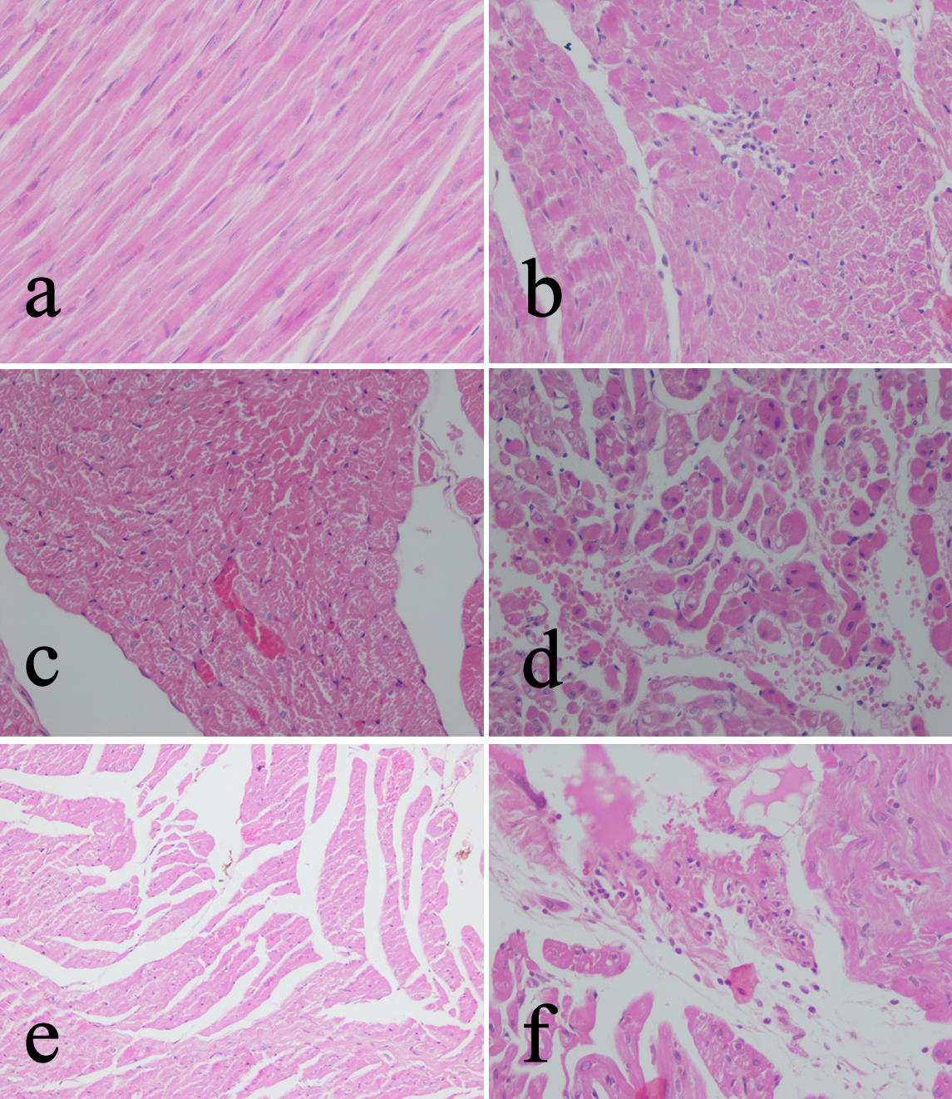

Figure 1. a) Control group, Normal rat myocardial tissue (HE x 200); b) Mild inflammation, Dexmedetomidine Group: Rat myocardial tissue (HE x100); c) Mild myonecrosis, Dexmedetomidine Group: Rat myocardial tissue, (HEx200); d) Mild edema and myonecrosis, Ischemia Reperfusion - Dexmedetomidine Group Rat myocardial tissue, (HEx 100)
; e) Moderate edema, Ischemia reperfusion group: Rat myocardial tissue, (HEx 100);

