BREAST UPTAKE OF GA-68 DOTA-TATE IN A NURSING WOMAN WITH NET DIAGNOSIS

Abstract: Neuroendocrine tumors are heterogenous group of tumors that expresses somatostatin receptors on their cell surfaces. PET/CT with Ga-68 labeled somatostatin analogues has been used as an important imaging modality in the NETs. It’s important to know normal biodistribution of radiotracer to avoid misinterpretation. We report physiologic breast uptake of Ga-68 in a nursing patient.

Introduction: Neuroendocrine tumors (NET) arise from the neuroendocrine cells and express somatostatin receptors (SSTRs). These tumors can originate from any organ through the body derived from the neural crest. Conventional imaging methods have limitations in these tumors because of small tumor size, variable location and low metabolic rate (1).
Somatostatin receptor scintigraphy (SRS) is an important imaging method in neuroendocrine tumors. Although SRS allows for whole-body imaging, there are some drawbacks such as imaging of organs with high physiological uptake and suboptimal physical resolution of the isotopes (2). Recently, PET/CT with Ga-68 labeled somatostatin analogues has been developed and has shown clear advantages including improved spatial resolution and pharmacokinetics (3). Knowledge of normal biodistribution of radiotracer is important when interpreting the PET/CT images. The pituitary, salivary glands, thyroid, liver, spleen, adrenals, pancreas, kidneys, ureters, and bladder are the organs that show physiological tracer uptake. However, up to our knowledge, physiologic breast uptake of Ga-68 in a lactating patient has not been reported previously. Here, we report bilateral breast uptake of Ga-68 DOTA-TATE in a nursing patient with NET diagnosis.

Case report: A 36-y-old female with a mass lesion at the junction of pancreatic body and tail was diagnosed as neuroendocrine tumor (Ki-67:1%). PET/CT with Gallium-68 (Ga-68) performed for staging demonstrated very intense tracer uptake at the pancreatic lesion (SUVmax: 48,9) (figure, arrow). There was also bilateral breast uptake in the patient who had been breast-feeding for 1 year.

Key-words: Ga-68, DOTA-TATE, PET/CT, lactation

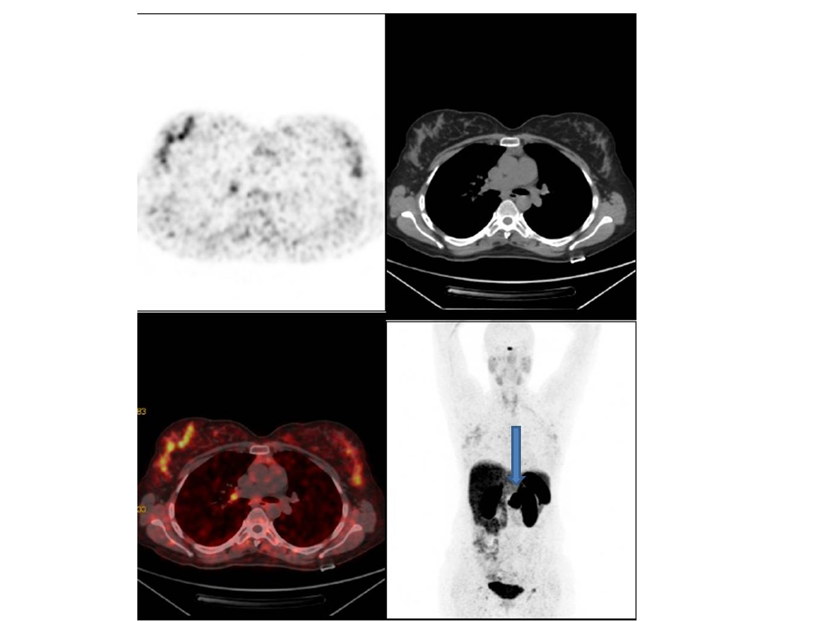

Discussion: Uptake of 18-fluorodeoxyglucose during breast-feeding is well documented (4-7). However, as far as we know, physiologic breast uptake of Ga-68 in a lactating patient has not been reported previously. The Ga-68-labeled somatostatin analog Ga-68 DOTA-D-Phe1-Tyr3-octreotate (Ga-68-DOTA-TATE) expresses increased affinity for somatostatin receptors-2 (SSTRs 2) (3). The physiologic uptake of DOTA-TATE was seen in the pituitary, salivary, thyroid glands, spleen, liver, adrenals and kidneys and excretory activity in the urinary tract. Kagna et al. demonstrated that the most common location of 68Ga-DOTA-NOC–avid sites other than NET was in small lymph nodes, followed by prostate, uterus, breasts, lungs, brown fat, musculoskeletal system, and other sites, including oropharynx, pineal body, thymus, aortic plaque, genitalia, surgical bed, and subcutaneous granuloma. They found 29 sites of diffuse 68Ga-DOTA-NOC uptake in the breasts in 14 of the 96 female patients with SUVmax range of 0.8–2.7. Low and variable expression of SSTR 2 has been reported in breast tissue unaffected by disease. In our case, we demonstrated Ga-68 DOTA-TATE uptake in the bilateral breasts in a nursing patient newly diagnosed with NET (8). Although tracer uptake of breast during breast-feeding is a well known phenomenon, this is the first case imaged by Ga-68 DOTA-TATE PET/CT.

References:
- Ramage JK, Davies AH, Ardill J, Bax N, Caplin M, Grossman A, et al. Guidelines for the management of gastroenteropancreatic neuroendocrine (including carcinoid) tumors. Gut. 2005;54(Suppl 4):iv1–16
- J. Kowalski, M. Henze, J. Schuhmacher, H. R. Mäcke, M. Hofmann, U. Haberkorn. Evaluation of positron emission tomography imaging using [⁶⁸Ga]-DOTA-D Phe1-Tyr3- octreotidein comparison to [111In]-DTPAOC SPECT. First results in patients with neuroendocrine tumors. Molecular Imaging and Biology, 2003;5:42–48
- V. Ambrosini, D. Campana, P. Tomassetti, G. Grassetto, D. Rubello, S. Fanti. PET/CT with 68Gallium-DOTA peptides in NET: an overview. European Journal of Radiology,2011;80:116–119
- Hicks RJ, Binns D, Stabin MG. Pattern of uptake and excretion of (18)F-FDG in the lactating breast. J Nucl Med. 2001;42(8):1238-42.
- Yasuda S, Fujii H, Takahashi W, Takagi S, Ide M, Shohtsu A. Lactating breast exhibiting high F-18 FDG uptake. Clin Nucl Med. 1998 Nov;23(11):767-8.
- Aksoy SY, Görtan FA, Özdemir E, Türkölmez Ş, Halac M, Sonmezoglu K. ₁₈F-FDG PET/CT imaging of breast cancer in a lactating woman. Rev Esp Med Nucl Imagen Mol. 2015 Nov 23.
- Ko KH, Jung HK, Jeon TJ. Diffuse intense 18F-FDG uptake at PET in unilateral breast related to breastfeeding practice. Korean J Radiol. 2013 May-Jun;14(3):400-2.
- Kagna O, Pirmisashvili N, Tshori S, Freedman N, Israel O, Krausz Y. Neuroendocrine tumor imaging with 68Ga-DOTA-NOC: physiologic and benign variants. AJR Am J Roentgenol. 2014 Dec;203(6):1317-23

Figure Legend: A 36-y-old female patient, 1 year postpartum, with NET diagnosis underwent Ga-68 DOTA-TATE PET/CT for staging. Axial PET, CT, fusion and MIP images revealed bilateral breast uptake of Ga-68 DOTA-TATE which was more prominent on the right side. There was also pancreatic lesion with intense Ga-68 accumulation (arrow).

